HELIOS
Interface Editor
User Manual
Build, maintain and troubleshoot DCS World interfaces for Helios
A complete guide for first-time users covering every menu, tab, button and workflow.
Contents
Introduction 1
About Helios Interface Editor 1
1.1 What the Helios Interface Editor does 1
1.2 Who this manual is for 1
1.3 Words used in this manual 1
1.4 About the screenshots 1
2. Installing and Starting the Editor 1
Part A – Using the packaged program (PyInstaller build) 1
2.1 What you need 1
2.2 Installing it 1
2.3 Starting the editor 1
2.4 Updating to a new version 1
2.5 If the packaged program will not start 1
Part B – Working with the source code 1
2.6 Requirements 1
2.7 Starting the editor from source 1
2.8 Building your own packaged program with PyInstaller 1
2.9 Where files are stored 1
3. A Tour of the Main Window 1
3.1 The header 1
3.2 The four main tabs 1
3.3 The menu bar 1
3.4 Keyboard shortcuts 1
4. Quick Start: Your First Interface in Ten Steps 1
5. Building an Interface 1
5.1 Starting a new interface 1
5.2 Generating or loading a reference table 1
5.3 Building devices from the reference table 1
Right-click menu 1
Auto-fill Id's 1
5.4 Adding entries by hand 1
Push Button 1
Switch 1
Axis 1
Rotary Encoder 1
Network Value 1
Scaled Network Value 1
Flag Value 1
Text 1
Drawing Value 1
3D Ball 1
5.5 Collisions and Full View 1
6. Editing and Maintaining Entries 1
6.1 Editing an entry 1
6.2 Changing device names and IDs 1
6.3 Changing an entry's type 1
6.4 Duplicating entries 1
6.5 Deleting entries 1
6.6 Viewing devices 1
6.7 Fixing collisions 1
6.8 Searching the interface 1
6.9 Setting descriptions in bulk 1
6.10 Working with more than one interface 1
7. Opening, Saving and Exporting 1
7.1 Opening an interface 1
7.2 Saving 1
7.3 Reset 1
8. Keeping an Interface Up to Date 1
8.1 The routine 1
8.2 Current Data 1
8.3 Old References 1
8.4 Mismatched 1
8.5 Viewport and Source 1
9. The Aircraft Data Tab (Argument Logger) 1
9.1 One-time setup: the export hook 1
9.2 Choosing what to record 1
9.3 Logging 1
Reading the table 1
9.4 Filtering 1
9.5 Grouping commands 1
9.6 Change log 1
9.7 Turning findings into entries 1
10. The Text Editor Tab 1
11. Packaging a Profile 1
11.1 Before you package 1
11.2 Packaging steps 1
What goes into Profile16.json 1
Missing and unused images 1
11.3 Check Bindings 1
11.4 Monitor Removal 1
12. Appearance 1
13. Troubleshooting 1
13.1 Quick diagnosis table 1
13.2 If the editor will not start 1
13.3 If a saved interface will not load in Helios 1
13.4 If you lose work 1
13.5 A recommended maintenance checklist 1
Appendix A. Device Type Summary 1
Appendix B. Glossary 1

Introduction

About Helios Interface Editor
Helios Interface Editor was originally to replace the process of manually typing out interfaces for DCS. Through a lot of collaboration between MadKreator37 and IT_Mechanic, this was achieved pretty quickly. Then it proceeded to grow to be able to automatically gather all the relevant data to make building profiles even faster through the use of a parser. BlueFinBima contributed the Monitor removal scripts, and MadKreateor37 contributed the logger scripts. All of these were incorporated and refined into Helios Interface Editor to make it what it is today. A powerful assistant to the Helios Profile Editor. If you are reading this and are starting on your journey to develop profiles for DCS Helios congratulations welcome to the club.
IT_Mechanic

1.1 What the Helios Interface Editor does
Helios is a program that draws virtual cockpit instruments on extra monitors and sends your button presses, switch flips and knob turns back to DCS World. For Helios to talk to an aircraft it needs an interface: a file that lists every cockpit value Helios can read from the simulator (an export) and every cockpit control Helios can operate (an action).
The Helios Interface Editor is the tool you use to create and maintain those interface files. Instead of editing large JSON files by hand, you work in tables and forms. The editor also compares your interface with the aircraft's own definition files, finds mistakes, helps you package a finished profile for sharing, and can watch DCS while it runs to show you which cockpit values are changing.

1.2 Who this manual is for
This manual assumes you have never used the editor. It explains every screen, every button and every menu item, and walks through the full life of an interface: building it, maintaining it as the aircraft is updated, and troubleshooting it when something does not work. You do not need to know how to program. A basic familiarity with the aircraft you are working on and with Helios profiles is helpful.

1.3 Words used in this manual
Term | Meaning
Interface | A JSON file (for example DCS.MyJet.hif.json) describing the exports and actions Helios can use for one aircraft.
Device (entry) | One row in the interface: a push button, switch, axis, rotary encoder, network value, and so on. Each device has a name, a cockpit device, and the numbers that connect it to DCS.
Export ID (Arg) | The DCS cockpit argument number Helios reads to learn the current state of a control or gauge.
Device ID / Action ID | The DCS device number and command number Helios sends to operate a control.
Reference table | A JSON file the editor generates from the aircraft's Lua files. It lists every argument, device and command DCS knows about for that aircraft, and is the main source for building devices.
Old Reference | An earlier reference table that you load so the editor can show what changed after a DCS update.
Profile (.hpf) | A Helios profile: monitors, panels and gauges that use the interface.
Package (.helios16) | A single file containing a profile, its interface, images and installer information, ready to share.
Argument Logger | The part of the editor (the Aircraft Data tab) that reads values live from a running DCS session.

1.4 About the screenshots
Note All screenshots were captured with a sample aircraft called "MyJet" and sample data on a virtual display, so they have no window title bars and show Linux-style file paths and Tk file dialogs. On your Windows computer the same windows appear with normal title bars and the standard Windows Open/Save dialogs. Everything else, including the layout, buttons and colours, is identical.

2. Installing and Starting the Editor
The editor reaches you in one of two forms. Most people receive the packaged program: a ready-to-run Windows application that was already built from the source code with PyInstaller. Developers and people who want to change the editor work with the source code instead. Follow the part that matches what you have; everything from chapter 3 onward is identical for both.
If you have… | Go to | Python needed?
A folder or zip containing Helios_Interface_Editor.exe (or similar) | Part A – Using the packaged program (sections 2.1 to 2.5) | No
A file named Helios_Interface_Editor.py | Part B – Working with the source code (sections 2.6 to 2.8) | Yes

Part A – Using the packaged program (PyInstaller build)
A PyInstaller build bundles Python, the editor and its built-in Text Editor into one application, so nothing else has to be installed.

2.1 What you need
- A Windows PC with DCS World installed. The editor reads aircraft files from the DCS installation and from your Saved Games folder.
- Helios installed, so the interface files you create can be used (they are saved in your Documents\Helios\Interfaces folder).
- The packaged editor folder or zip, including the companion file ArgumentLogger_For_PythonGUI.lua. This Lua file is needed only for the Aircraft Data tab (the logger).

2.2 Installing it
There is no installer. You simply place the folder somewhere permanent.
- If you received a zip file, right-click it and choose Extract All… Do not run the program from inside the zip; Windows would run it from a temporary location and the companion files would be missing.
- Move the extracted folder to a place you can write to and will remember, for example C:\Helios Interface Editor. Avoid C:\Program Files.
- Keep the folder together. Check that it contains the program (Helios_Interface_Editor.exe or your build's name) and ArgumentLogger_For_PythonGUI.lua. If your build is a one-folder build it also contains a folder named _internal; leave it exactly where it is, because the program cannot start without it. A one-file build is just the single .exe plus the Lua file.
- Make sure ArgumentLogger_For_PythonGUI.lua sits directly beside the .exe, not inside _internal. The logger looks for it in the folder the .exe lives in.

2.3 Starting the editor
- Double-click the .exe. A one-file build can take several seconds to unpack the first time.
- If Windows shows a blue Windows protected your PC (SmartScreen) message, click More info and then Run anyway. This appears for any program that is not commercially signed.
- The main window opens, empty, with the title HELIOS INTERFACE EDITOR. You are ready for chapter 3.
Tip Right-click the .exe and choose Send to > Desktop (create shortcut), or Pin to taskbar, so you can start it quickly. The shortcut can live anywhere, but the .exe itself must stay in its folder next to the Lua file.

2.4 Updating to a new version
- Close the editor.
- Replace the old folder's contents with the new build (keep the _internal folder if there is one, and the Lua file beside the .exe).
- Start it as before. Your interfaces, reference tables, profiles and packages are stored in Documents\Helios and in your Saved Games folder, not in the program folder, so they are not touched.

2.5 If the packaged program will not start
Symptom | What to try
Nothing happens after double-clicking, or the .exe disappears | Your antivirus may have quarantined it. Restore it and add the folder to the antivirus exceptions.
Windows blocks it with a SmartScreen message | Click More info > Run anyway (section 2.3). If there is no such option, right-click the .exe, choose Properties and tick Unblock at the bottom of the General tab.
A message about a missing file or the program closes at once (one-folder build) | The _internal folder was moved, renamed or left behind. Restore it beside the .exe.
The program starts but the Aircraft Data tab says it cannot find the logger script | ArgumentLogger_For_PythonGUI.lua is not directly beside the .exe. Copy it there.
The window has a plain icon instead of the Helios icon | Harmless. The icon file was not included in this build.
You want to see an error message | Open Command Prompt, change to the program folder and run the .exe from there; a build made with a console window will print the error.

Part B – Working with the source code
Use this route if you were given Helios_Interface_Editor.py, want to modify the editor, or want to build your own packaged version.

2.6 Requirements
- A Windows PC with DCS World installed (the editor reads aircraft files from the DCS installation and from your Saved Games folder).
- Python 3 with Tkinter. Tkinter is included in the standard Python installer for Windows; keep tcl/tk and IDLE ticked during installation. To test, run python -m tkinter in a Command Prompt: a small window should appear.
- The two companion files kept in the same folder as the editor: Text_Editor_Prototype.py (the built-in text editor, imported by the editor) and ArgumentLogger_For_PythonGUI.lua (the Lua script that lets the logger read DCS).
- Helios installed, so interface files can be placed in your Documents\Helios\Interfaces folder.
- Optional: tkinterdnd2 (pip install tkinterdnd2) enables drag-and-drop of files onto the editor. Without it the editor works normally but drag-and-drop is switched off.
- Optional: parser_engine.py in the same folder improves how device names are prettified. The editor runs without it.
- Optional: an assets folder containing Helios Interface Editor.ico gives the window its icon.

2.7 Starting the editor from source
- Put the three files in the same folder.
- Open a Command Prompt in that folder (type cmd in the folder's address bar and press Enter).
- Run python Helios_Interface_Editor.py.
- The main window opens, empty, with the title HELIOS INTERFACE EDITOR.
Tip You can also double-click the .py file if Python is associated with it, or create a desktop shortcut that runs the command above. If the python command is not found, try py Helios_Interface_Editor.py.

2.8 Building your own packaged program with PyInstaller
If you want to produce the Part A version yourself, install PyInstaller and build from the source folder.
- Run pip install pyinstaller (and pip install tkinterdnd2 if you want drag-and-drop in the build).
- From the folder holding the source files run pyinstaller --noconsole --name Helios_Interface_Editor Helios_Interface_Editor.py. Add --onefile for a single .exe instead of a folder. Add --icon with your .ico file to set the program icon. Add --add-data for an assets folder if you want the window icon inside the build.
- PyInstaller creates a dist folder. Open dist\Helios_Interface_Editor (or the single .exe in dist).
- Copy ArgumentLogger_For_PythonGUI.lua into that same folder, beside the .exe. PyInstaller does not include it automatically, and the logger will not work without it.
- Test the build by double-clicking the .exe, then hand out the whole folder (or the .exe plus the Lua file).
Note Remove --noconsole while testing if you want a console window that prints errors. The Text Editor needs no extra step because PyInstaller finds and bundles Text_Editor_Prototype.py on its own.

2.9 Where files are stored
Item | Default location
Interfaces | Documents\Helios\Interfaces\HeliosInterfaces
Reference tables | Documents\Helios\Interface Editor\Reference Tables
Packages | Documents\Helios\Interface Editor\Profile Exports
Profiles | Documents\Helios\Profiles
Profile images | Documents\Helios\Images
Aircraft Lua files | Your DCS installation, under Mods\aircraft\<Aircraft>

3. A Tour of the Main Window
When you open an interface, the window looks like Figure 1. This chapter names every area so the rest of the manual is easy to follow.
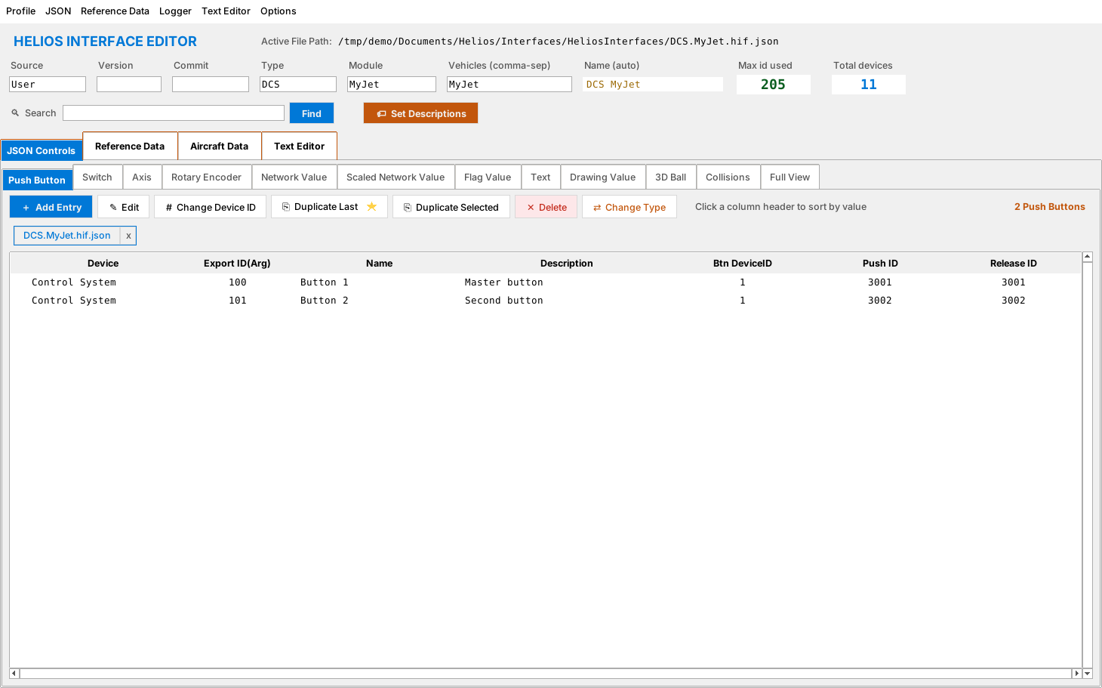
Figure 1. The main window with the JSON Controls tab open

3.1 The header
The header runs across the top and describes the interface as a whole. Every field is editable.
Field | What to enter
Active File Path | Read-only. The interface file currently open.
Source | Free text saying where the interface came from (for example User).
Version | Optional version label for your interface.
Commit | Optional source-control commit identifier.
Type | DCS or Helios. Sets the file name prefix.
Module | The DCS aircraft module name (for example F-16C_50). Must match DCS exactly.
Vehicles (comma-sep) | The vehicle names this interface applies to, separated by commas.
Name (auto) | Built automatically from Type and Module. Read-only.
Max id used | The highest Export ID in the interface. Use the next number up for new entries.
Total devices | How many entries the interface contains.
Search + Find | Search every device tab for text (see section 6.8).
Set Descriptions | Fills in descriptions for devices (see section 6.9).

3.2 The four main tabs
Tab | Purpose
JSON Controls | Create and edit the devices in the interface.
Reference Data | Load, build and compare the aircraft reference table; build devices from it.
Aircraft Data | The Argument Logger. Watches DCS live.
Text Editor | Edit JSON and other text files, with live sync to the open interface.

3.3 The menu bar
The menu bar has six menus. Each is explained in full in the chapter that uses it.
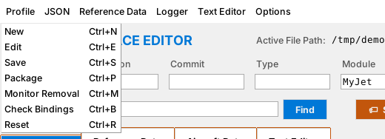
Figure 2. The Profile menu
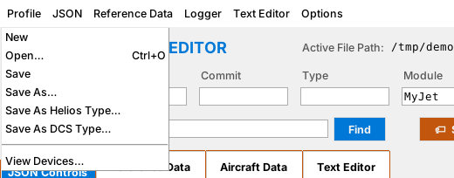
Figure 3. The JSON menu
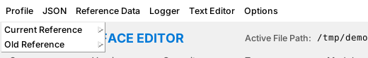
Figure 4. The Reference Data menu
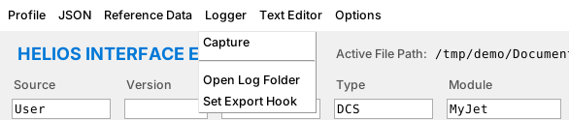
Figure 5. The Logger menu
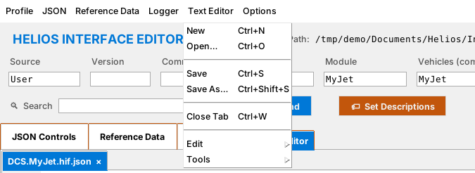
Figure 6. The Text Editor menu
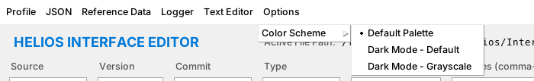
Figure 7. The Options menu with the Color Scheme submenu

3.4 Keyboard shortcuts
Shortcut |  | Action
Ctrl+N |  | Profile: New (in the Text Editor tab: new text file)
Ctrl+E |  | Profile: Edit an existing interface
Ctrl+S |  | Profile: Save (Text Editor tab: save file)
Ctrl+P |  | Profile: Package
Ctrl+M |  | Profile: Monitor Removal
Ctrl+B |  | Profile: Check Bindings
Ctrl+R |  | Profile: Reset (close everything)
Ctrl+O |  | JSON: Open
Ctrl+G |  | Reference Data: Generate current reference
Ctrl+Z / Ctrl+Y |  | Undo / Redo in the Text Editor
Ctrl+X / C / V / A |  | Cut / Copy / Paste / Select All
Ctrl+F / F3 |  | Find / Find Next in the Text Editor
Ctrl+Shift+S |  | Text Editor: Save As
Ctrl+W |  | Text Editor: Close Tab
Ctrl+Tab |  | Switch between open tabs
 | Note Some shortcuts depend on which tab is active. Ctrl+N, Ctrl+O and Ctrl+S act on the Text Editor when its tab is showing and on the interface otherwise.

4. Quick Start: Your First Interface in Ten Steps
This chapter is a complete walkthrough from nothing to a saved, working interface. Later chapters explain each step in depth.
- Choose Profile > New (Ctrl+N).
- In the folder chooser, select the aircraft folder under your DCS installation (for example Mods\aircraft\F-16C). The editor creates a new interface with Module set to the folder name.
- The editor reads the aircraft's Lua files and builds a reference table. When it finishes, open the Reference Data tab to see it.
- On Reference Data > Current Data, select the rows for one cockpit control (for example a switch) and click Build Device.
- Check the details in the Device Information dialog and click Create device.
- Repeat for each control you want. Use Auto-fill Id's to assign unused Export IDs automatically.
- Go back to JSON Controls and review the new entries on each device tab.
- Fix descriptions with Set Descriptions and check the Collisions tab for duplicate IDs.
- Choose Profile > Save (Ctrl+S). Pick a sort order when asked.
- Open Helios, load your profile, and test the controls. Use the Aircraft Data tab if something does not respond.
Tip Everything in this chapter can be undone by closing without saving, or by reopening the saved interface with Profile > Edit.

5. Building an Interface

5.1 Starting a new interface
There are two ways to start. Profile > New (Ctrl+N) is the usual one: it selects an aircraft, creates an empty interface and generates the reference table in one go. JSON > New just clears the window for a blank interface without a reference table.
- Choose Profile > New.
- If you have unsaved work, the editor saves and closes it first.
- In the folder chooser, pick the aircraft's folder inside your DCS Mods\aircraft directory.
- The editor sets Module to the folder name, then reads the Lua files to generate the reference table.
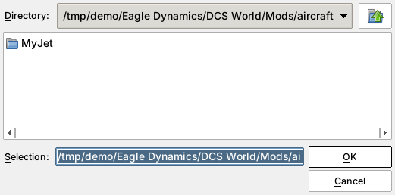
Figure 8. Choosing the aircraft folder
Note Fill in Type (DCS or Helios) and Vehicles in the header now. The editor uses them for the file name and for matching profiles later.

5.2 Generating or loading a reference table
The reference table is the aircraft's own list of arguments, devices and commands. With Profile > New it is created for you. You can also manage it yourself from the Reference Data menu.
Menu item | What it does
Current Reference > Generate… (Ctrl+G) | Reads the aircraft folder and builds a fresh table.
Current Reference > Load… | Opens a saved reference table JSON file.
Current Reference > Load additional viewports… | Adds viewport definitions from another file to the current table.
Current Reference > Save / Save As… | Writes the current table to disk.
Old Reference > Load… | Loads an earlier table for comparison (see chapter 8).
Old Reference > Save / Save As… | Writes the old table back to disk.
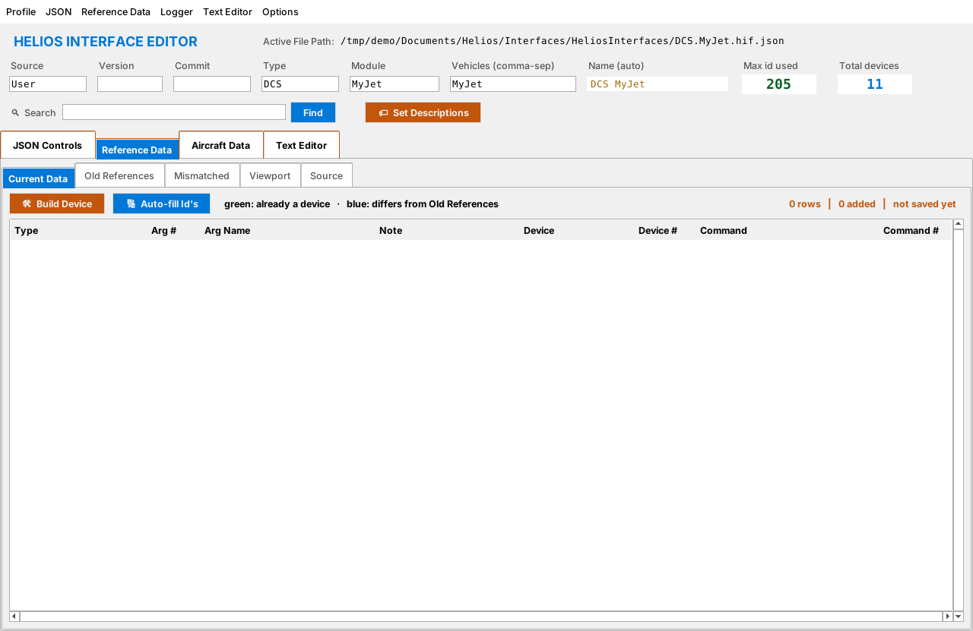
Figure 9. Reference Data > Current Data before a table is loaded
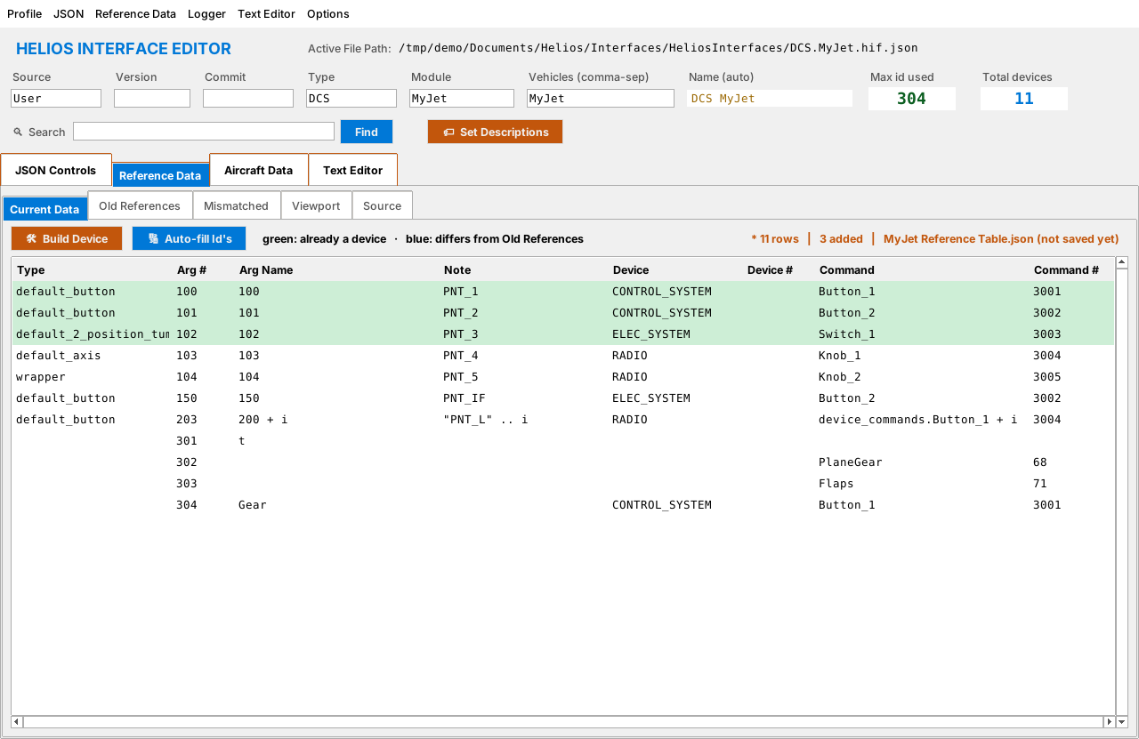
Figure 10. Reference Data > Current Data after generating a table
Each row of the table is one thing DCS knows about. The columns are:
Column | Meaning
Type | The kind of control as DCS describes it (for example default_button, default_axis, default_2_position_tumb, wrapper).
Arg # | The cockpit argument number. This becomes the Export ID.
Arg Name | The label in the Lua file for that argument.
Note | Any note recorded alongside the argument.
Device | The cockpit device (for example RADIO).
Device # | The numeric device ID, when known.
Command | The command name.
Command # | The command (action) number. This becomes the Action ID.
Rows are colour-coded: green means the row is already a device in your interface, and blue means the row differs from the Old Reference. A status line at the right reports the number of rows, how many have been added to the interface, and the table file name (marked "not saved yet" until you save).

5.3 Building devices from the reference table
This is the fastest way to build an interface, because the editor fills in the numbers for you.
- On Reference Data > Current Data, click a row. To build one device from several rows (a switch with separate command rows, for example) Ctrl+click or Shift+click to select them all.
- Click Build Device.
- The Device Information dialog opens (Figure below). Review the Export ID, Device, Action ID and Description, and pick the Device type.
- Choose a Name using one of four options: the Help text, the Arg Name, the Command name, or type your own.
- Click Create device to add it, Review in Add dialog… to fine-tune it in the full Add Entry form, Combine to merge the selected rows into one device, Skip to move on, or Cancel to stop.
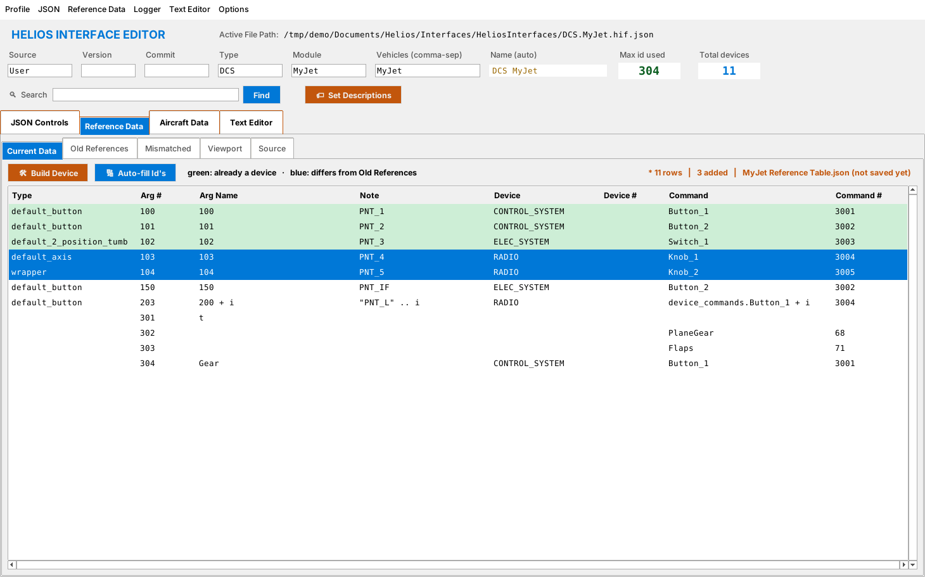
Figure 11. Two rows selected, ready to build
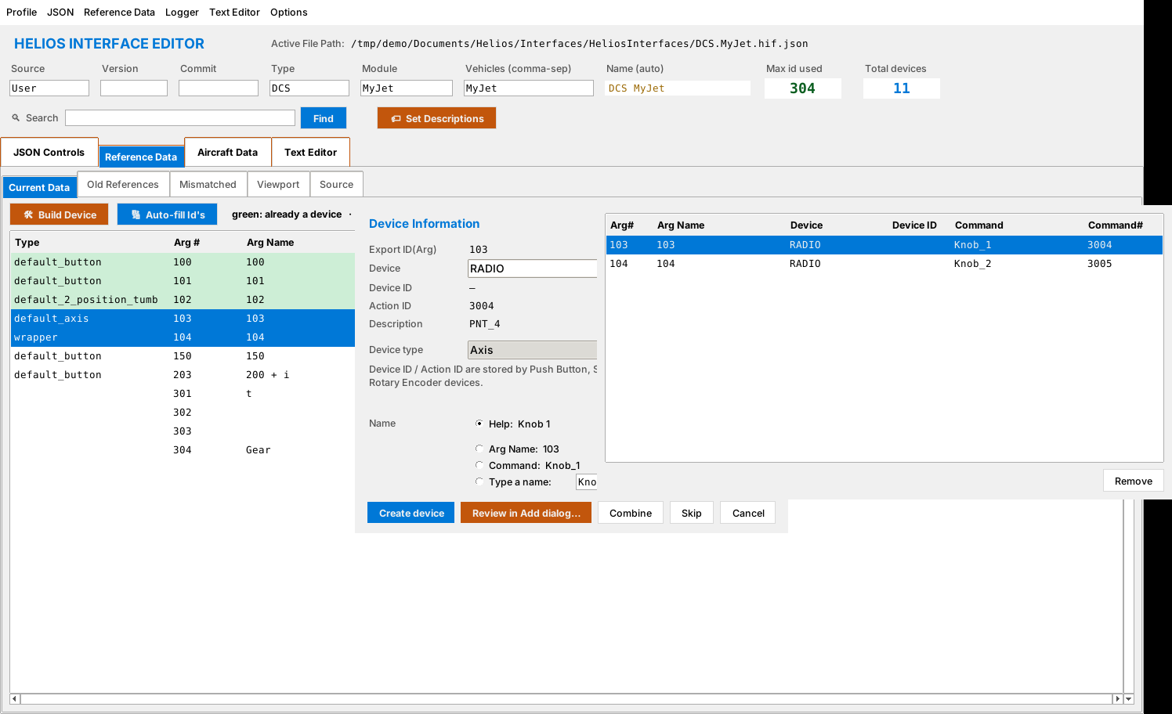
Figure 12. The Device Information dialog and the Selection window
The Selection window on the right lists every row in the batch. Select a row and click Remove to drop it from the batch without touching the reference table.

Right-click menu
Right-click a row in Current Data for three extra commands.
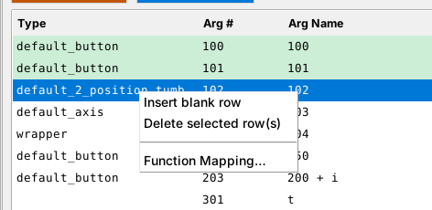
Figure 13. The row context menu
- Insert blank row adds an empty row above the click so you can type your own argument.
- Delete selected row(s) removes rows from the table (not from the interface).
- Function Mapping… opens a window listing every Lua control function found in the aircraft files (such as default_button or default_axis), the name of the parameter each one uses for its hint, device, command and argument, and the file that defines it. Export Mapping as JSON… saves that list to a file.
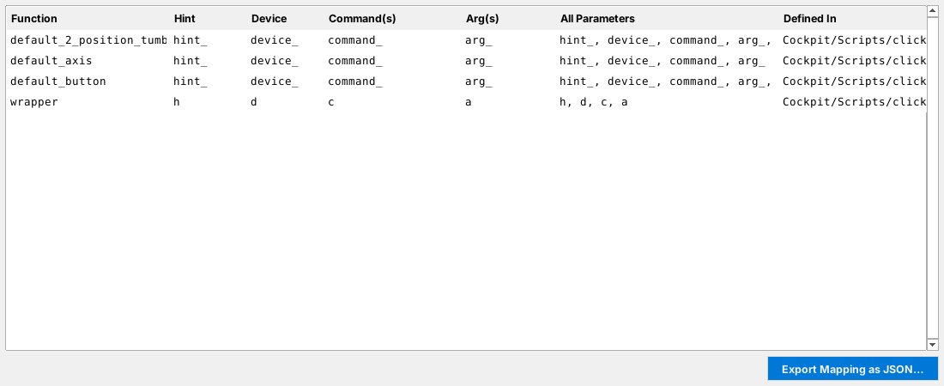
Figure 14. Function Mapping window

Auto-fill Id's
Rows that DCS defines with a pattern (such as 200 + i) or that have no argument number cannot be used directly. Auto-fill Id's gives those rows free argument numbers starting after your current Max id used, so you never clash with an existing ID.
Caution Auto-fill assigns numbers that DCS itself does not export. Those entries will not show live values until the aircraft's Lua export code is changed to match, so use them only for entries you are going to wire up yourself.

5.4 Adding entries by hand
You can also add any entry yourself. Go to JSON Controls, open the tab for the device type you want and click ＋ Add Entry. A form opens with all the fields for that type. Fields marked with an asterisk are required. Click Save Entry to add the device, or Cancel to discard it.
Note Pick the tab first: the Add Entry button always creates the type of the tab you are on.
Every type shares four Core fields:
Field | Meaning
Export ID(Arg) * | The DCS argument number Helios reads. Must be unique in the interface.
Device * | The cockpit device this belongs to (for example ELEC_SYSTEM).
Name * | The name shown in Helios.
Description | Free text shown to the profile builder. Pre-filled with a suggestion.

The type-specific fields follow.

Push Button
Use for a control that is pressed and released, such as a momentary button. Helios reads the button state from the export and sends a push and a release action.
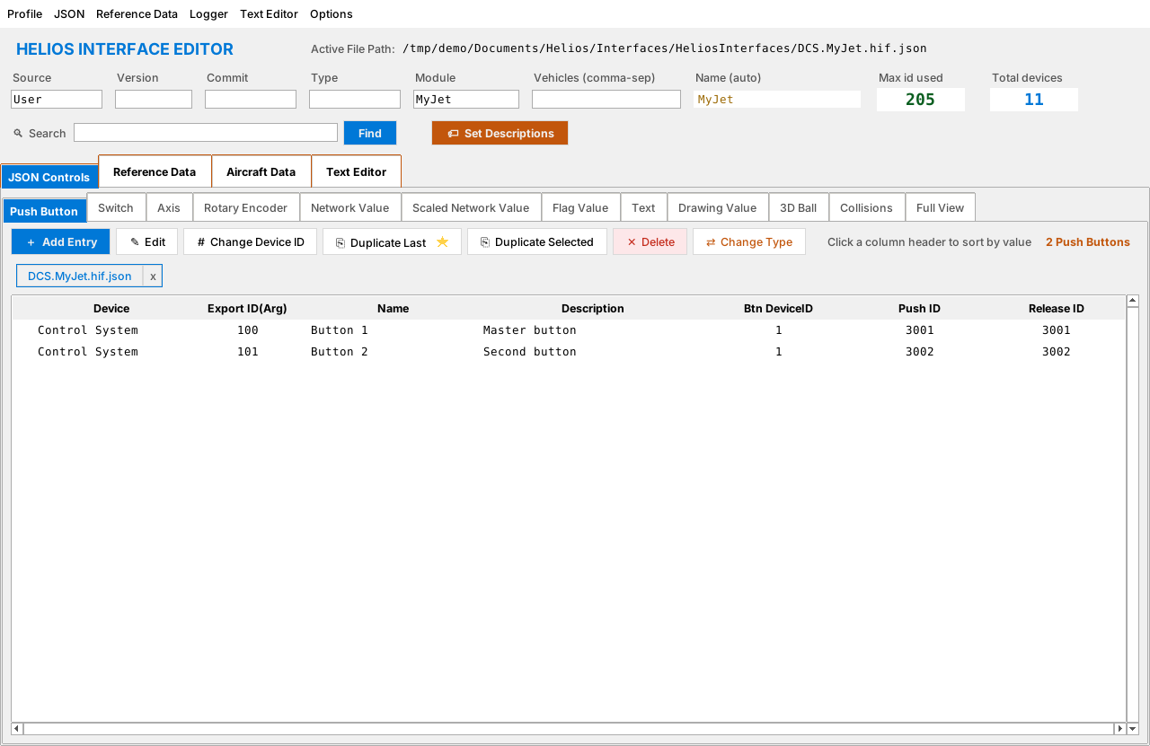
Figure 15. Push Button tab
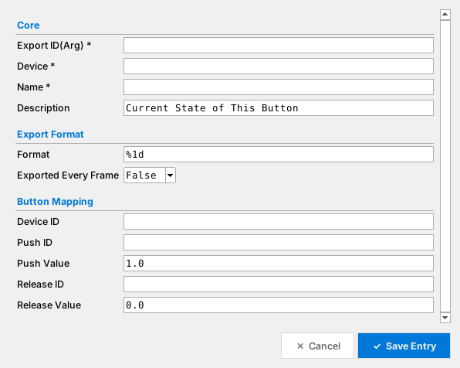
Figure 16. Add Entry dialog for Push Button
Field | Meaning
Format | How the number is printed. %1d shows a whole number.
Exported Every Frame | Choose True only for values that change constantly. Leave False otherwise to save bandwidth.
Device ID | The DCS device that receives the command.
Push ID / Push Value | The command sent when the button is pressed, and the value sent with it (default 1.0).
Release ID / Release Value | The command and value sent on release (default 0.0).

Switch
Use for a toggle or multi-position switch. You choose how many positions it has and what value DCS uses for each one.
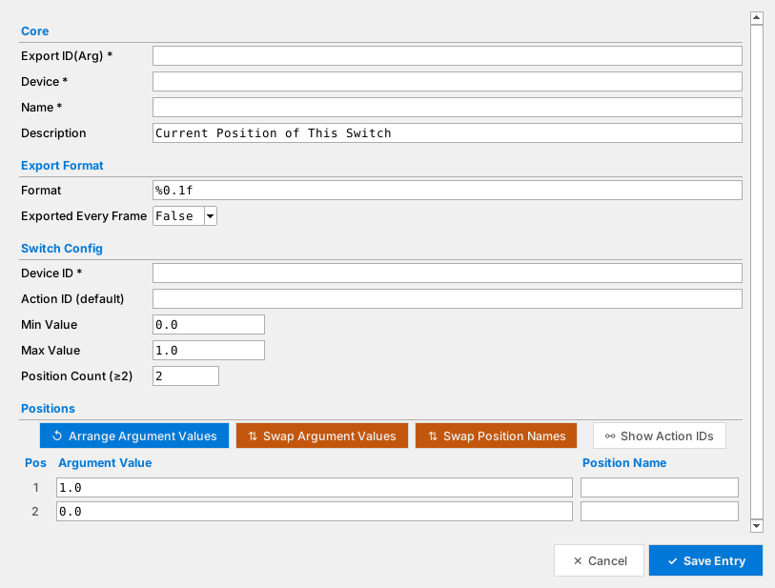
Figure 17. Add Entry dialog for Switch
Field | Meaning
Format | Number format (default %0.1f).
Exported Every Frame | True or False, as above.
Device ID * | The DCS device that receives the command.
Action ID (default) | The command sent when the switch changes.
Min Value / Max Value | Lowest and highest argument value.
Position Count (≥2) | Number of positions. The table below the field resizes to match.
Positions table | One row per position. Argument Value is the value DCS reports in that position; Position Name is the label shown in Helios.
Arrange Argument Values | Spreads the argument values evenly between Min and Max.
Swap Argument Values / Swap Position Names | Reverses the order of the values or names, for switches wired the opposite way.
Show Action IDs | Reveals an extra column so each position can have its own action ID.

Axis
Use for a continuous control such as a potentiometer or lever.
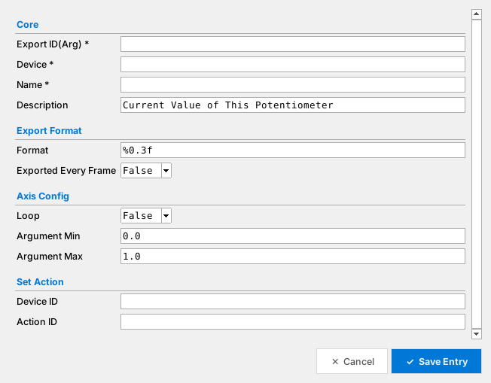
Figure 18. Add Entry dialog for Axis
Field | Meaning
Format | Default %0.3f.
Loop | True if the control wraps around (a 360° dial).
Argument Min / Max | Range of the argument value (default 0.0 to 1.0).
Device ID / Action ID | The DCS device and command used to set the value.

Rotary Encoder
Use for an endless knob that clicks up or down.
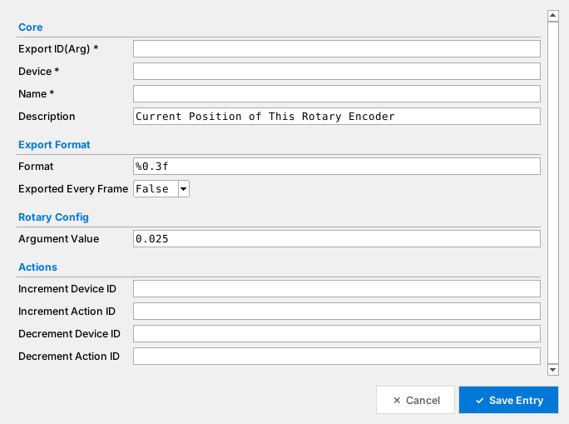
Figure 19. Add Entry dialog for Rotary Encoder
Field | Meaning
Argument Value | The size of one step (default 0.025).
Increment Device ID / Action ID | The command sent when the knob turns clockwise.
Decrement Device ID / Action ID | The command sent when the knob turns anticlockwise.

Network Value
Use for a plain number that Helios only reads, such as a gauge value between 0 and 1. It has no action.
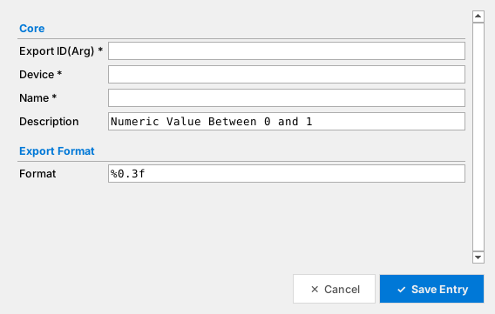
Figure 20. Add Entry dialog for Network Value
Field | Meaning
Format | Default %0.3f.

Scaled Network Value
Use when DCS exports a value between fixed limits (for example 0 to 1) and you want Helios to see it in real units, such as RPM or pounds of fuel.
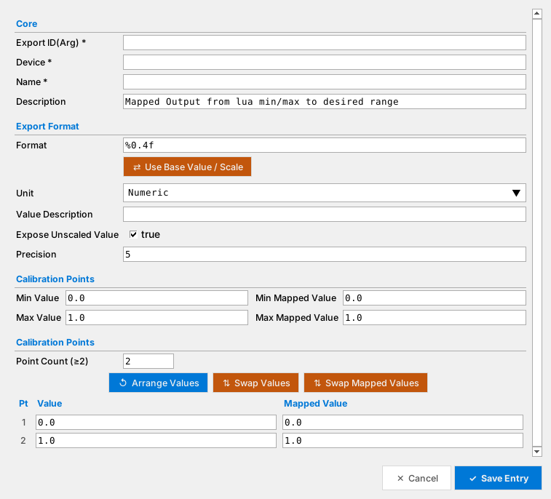
Figure 21. Add Entry dialog for Scaled Network Value
Field | Meaning
Format | Default %0.4f.
Use Base Value / Scale | Switches the calibration between Min/Max pairs and base value with scale factor.
Unit | The measurement unit chosen from a drop-down list (Numeric by default).
Value Description | Text describing the value.
Expose Unscaled Value | When ticked, the raw DCS value is also available to Helios.
Precision | Digits after the decimal point.
Min / Max Value, Min / Max Mapped Value | The simplest calibration: what DCS reports at each end, and the real-world value that means.
Point Count (≥2) | Add more calibration points for non-linear gauges. A row appears for each.
Arrange Values / Swap Values / Swap Mapped Values | Helpers that spread or reverse the point lists.
If a gauge reports 0.0 when empty and 1.0 when full and the real range is 0 to 3000 lb, set Min Value 0, Max Value 1, Min Mapped Value 0, Max Mapped Value 3000.

Flag Value
Use for an on/off indicator light.
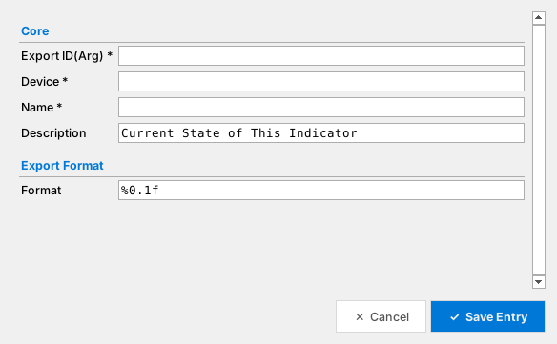
Figure 22. Add Entry dialog for Flag Value
Field | Meaning
Format | Default %0.1f.

Text
Use for values that arrive as text, such as a radio frequency display.
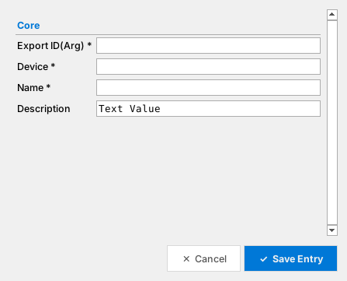
Figure 23. Add Entry dialog for Text
Field | Meaning
(Core fields only) | Text entries have no extra settings.

Drawing Value
Use for values that drive a drawn element, such as a canopy position, taken from an aircraft draw argument.
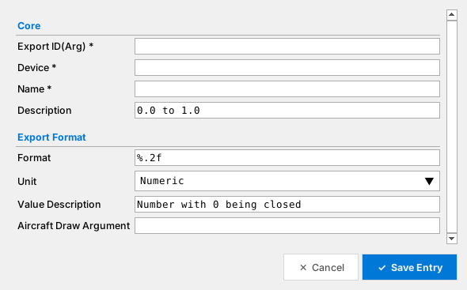
Figure 24. Add Entry dialog for Drawing Value
Field | Meaning
Format | Default %.2f.
Unit | Unit chosen from a drop-down list.
Value Description | Text describing the value (for example "Number with 0 being closed").
Aircraft Draw Argument | The draw argument number from the aircraft model.

3D Ball
Use for an attitude indicator ball where one export carries X, Y and Z movement. Each axis has its own calibration.
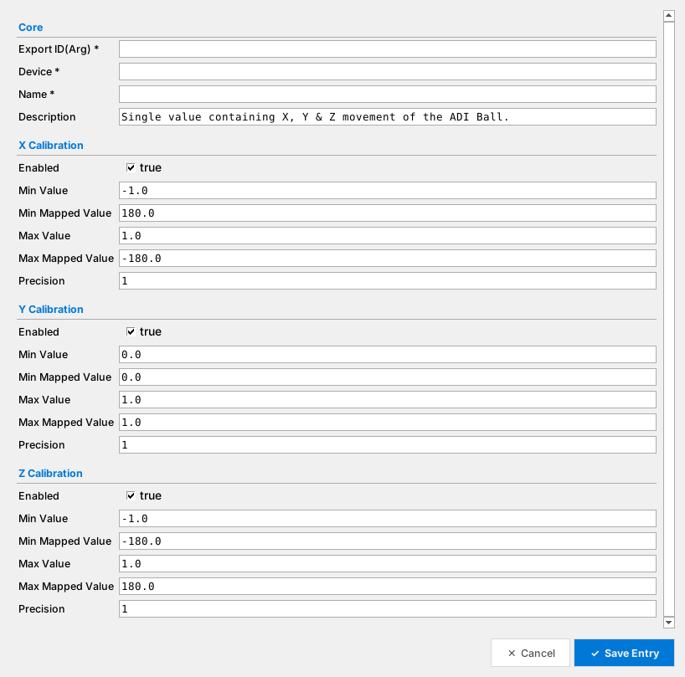
Figure 25. Add Entry dialog for 3D Ball
Field | Meaning
Enabled | Tick for each axis the ball uses.
Min / Max Value | The DCS values at each end of the axis.
Min / Max Mapped Value | The angle in degrees those values should become.
Precision | Digits after the decimal point.

5.5 Collisions and Full View
Two extra tabs help you check the whole interface rather than one type.
Collisions lists functions that share an Export ID(Arg), a Device ID + Action ID pair, or a Device + Name pair. Each group is headed by a warning line, and the clashing value is highlighted in every row of the group. Double-click a row to jump to that device, change one of the clashing values, then click Refresh. An empty list means no clashes.
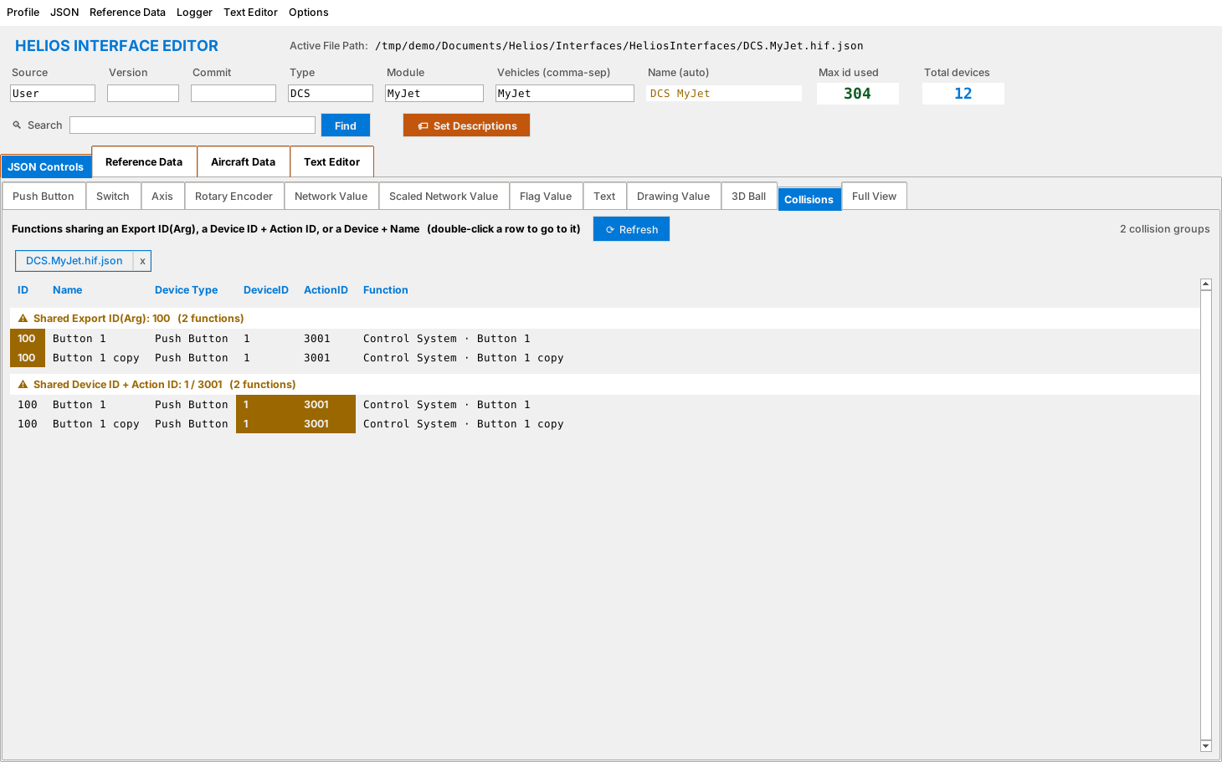
Figure 26. A collision list showing a duplicate entry
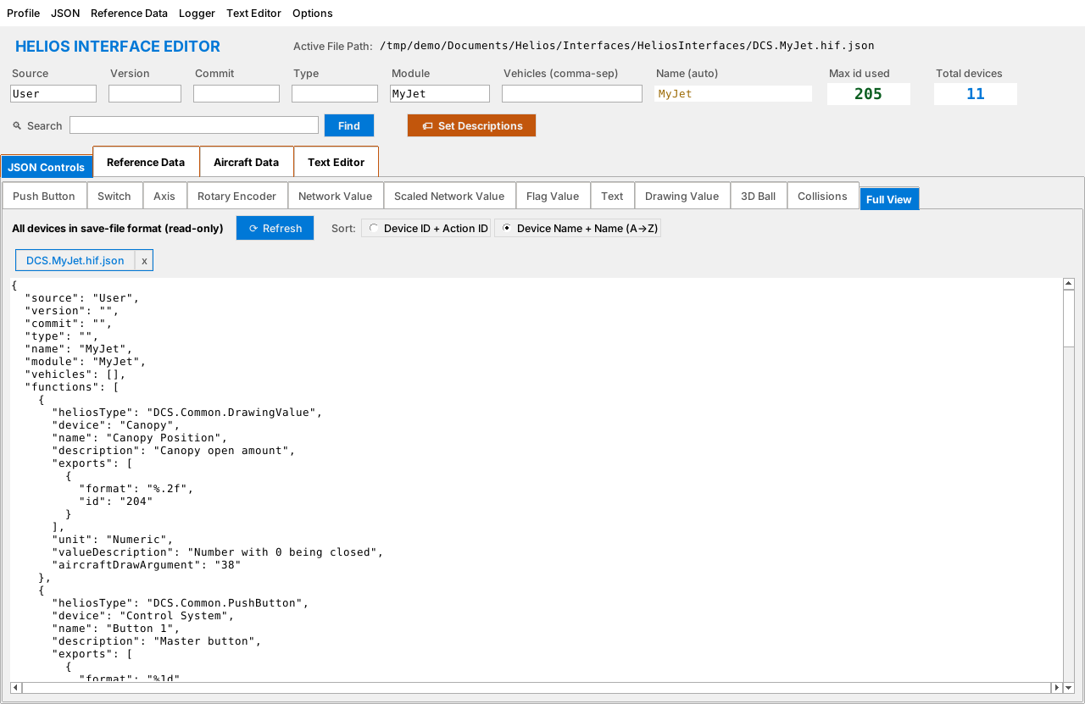
Figure 27. The Full View tab
Full View shows the whole interface exactly as it will be written to the JSON file. It is read-only. Choose how it is sorted (Device ID + Action ID or Device Name + Name) and click Refresh after making changes. It is useful for a final review.

6. Editing and Maintaining Entries
Once entries exist you will need to change them. All the tools below sit on the toolbar at the top of every device tab and act on the rows you select in the table.
Figure 28. The toolbar and table on a device tab
Button | What it does
＋ Add Entry | Opens the blank form for this tab's type (see section 5.4).
✎ Edit | Opens the selected entry in the same form, filled in. Double-clicking a row does the same.
# Change Device ID | Changes the Device name and Device ID of one or many entries at once (section 6.2).
⎘ Duplicate Last | Copies the entry you added most recently, which is quick for a series of similar controls.
⎘ Duplicate Selected | Copies the one selected entry. The copy is named "… copy" and keeps the same IDs, so give it new IDs afterwards. It works on a single row; select just one.
✕ Delete | Removes the selected entries after you confirm.
⇄ Change Type | Converts the selected entries to another device type (section 6.3).
The label at the right of the toolbar counts how many entries the tab holds. Click a column header to sort the table by that column; click again to reverse the order.

6.1 Editing an entry
- Select the row and click ✎ Edit, or double-click the row.
- Change any field in the form.
- Click Save Entry. The table updates immediately.
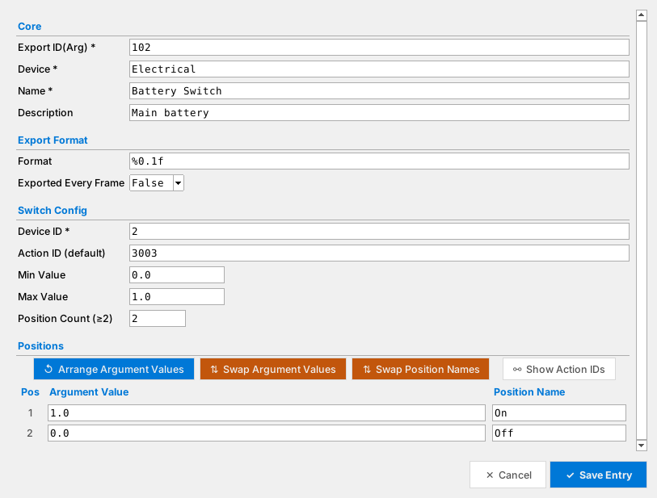
Figure 29. Editing a switch
Note Changing an entry only changes your open interface. Nothing is written to disk until you save (chapter 7).

6.2 Changing device names and IDs
If a cockpit device was renamed or renumbered in an aircraft update, you can fix every affected entry in one step.
- Select one or more rows on any device tab.
- Click # Change Device ID.
- The dialog shows the Current Device and Current Device ID. Type the New Device Name and New Device ID.
- Click Apply to Selection to change only the highlighted rows in the list on the right, or Apply to All to change every entry that currently uses that device.
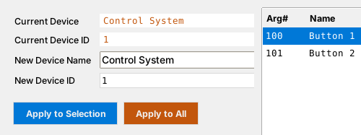
Figure 30. The Change Device ID dialog

6.3 Changing an entry's type
When an entry was created as the wrong type (for example a Network Value that should be a Switch), use Change Type.
- Select the rows.
- Click ⇄ Change Type.
- Pick the New type in the drop-down.
- Click Change Type.
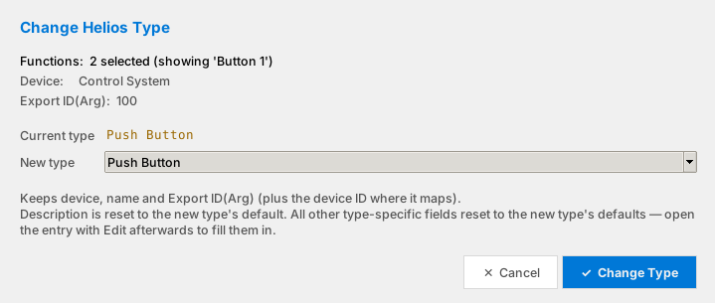
Figure 31. The Change Helios Type dialog
Caution The device, name and Export ID are kept, but the description and all type-specific settings are reset to the new type's defaults. Open each converted entry with ✎ Edit afterwards and fill in the details.

6.4 Duplicating entries
Use Duplicate Last while entering many similar controls. For example, after adding "Switch 1", press Duplicate Last, then Edit the copy, rename it and give it a new Export ID. Duplicate Selected does the same for the one row you select. Duplicates deliberately keep the original IDs, so the Collisions tab will flag them until you change them.

6.5 Deleting entries
Select rows and click ✕ Delete, then answer Yes to the Confirm Delete prompt. There is no undo, so if you are unsure, save a copy first with JSON > Save As….

6.6 Viewing devices
JSON > View Devices… opens a window that lists the entries of a single cockpit device. Choose the device from the drop-down at the top. Double-click a row to show that entry on its own tab.
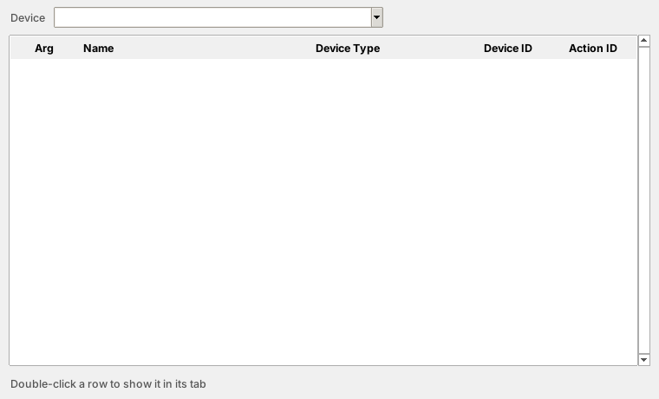
Figure 32. The View Devices window

6.7 Fixing collisions
After any edit that changes IDs, open the Collisions tab (section 5.5) and make sure it is empty. Helios behaves unpredictably when two controls share an Export ID or a command.

6.8 Searching the interface
Type text in the Search box in the header and click Find. A results window lists every entry whose name, device or description contains the text. Double-click a result to jump to it.
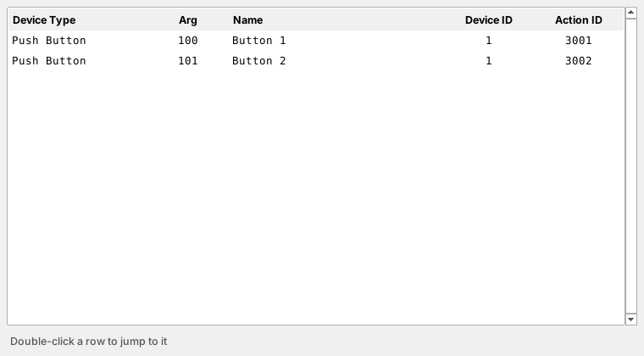
Figure 33. Search results

6.9 Setting descriptions in bulk
Set Descriptions fills empty or default descriptions for you, using the name of each control. It first asks what to cover.
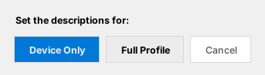
Figure 34. Choosing the scope for Set Descriptions
- Device Only updates the descriptions of the interface entries.
- Full Profile also updates the descriptions in the profile file that uses the interface.
- Cancel changes nothing.

6.10 Working with more than one interface
You can open several interfaces at once. Each one gets a small tab with its file name and an x to close it, shown just above the table. Switch between them to compare or copy entries.
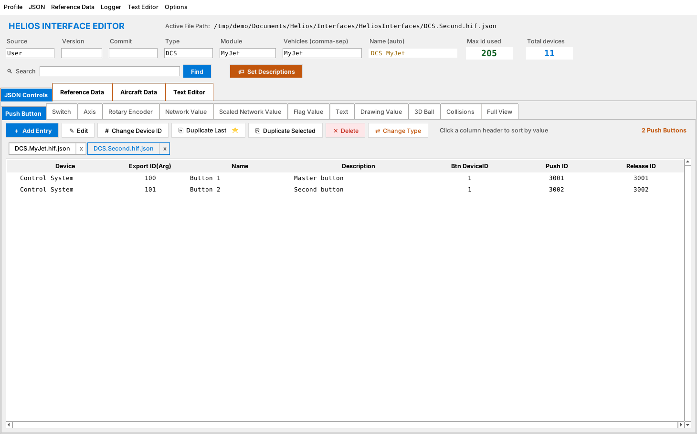
Figure 35. Two interfaces open at once

7. Opening, Saving and Exporting

7.1 Opening an interface
- Choose JSON > Open… (Ctrl+O) to open only the interface file, or Profile > Edit (Ctrl+E) to open the interface and then be asked for its reference table.
- Select a .hif.json file.
- The header and all device tabs fill in.

7.2 Saving
Command | Behaviour
JSON > Save | Saves the interface to its current file.
JSON > Save As… | Saves under a new name or location.
JSON > Save As Helios Type… | Saves a copy whose file name starts with Helios. (a Helios-type interface).
JSON > Save As DCS Type… | Saves a copy whose file name starts with DCS. (a DCS-type interface).
Profile > Save (Ctrl+S) | Saves the interface, then saves the reference table.
Whenever you save, the editor asks how to order the entries in the file.
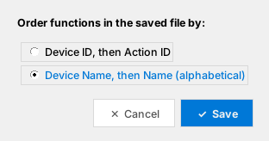
Figure 36. Choosing the sort order when saving
- Device ID, then Action ID orders entries by the numbers.
- Device Name, then Name (alphabetical) is easier to read and compare in a text editor.
Tip Pick one sort order and always use it. Entries then stay in a stable order, which makes differences between versions easy to see.

7.3 Reset
Profile > Reset (Ctrl+R) closes the interface, reference table and old reference, and returns the editor to its empty state. It asks for confirmation first.

8. Keeping an Interface Up to Date
Every DCS update can change argument numbers, commands and devices. The editor's Reference Data tools show exactly what changed.

8.1 The routine
- Before updating DCS, save the current reference table (Reference Data > Current Reference > Save As…).
- Update DCS.
- Open your interface and choose Reference Data > Current Reference > Generate… to build a fresh table.
- Load the old table with Old Reference > Load….
- Open Reference Data > Mismatched and review the differences.
- Press Update to carry the new values across, then re-check the Collisions tab.
- Save everything with Profile > Save.

8.2 Current Data
Rows you have already turned into devices are green. If the current table differs from the Old Reference, the changed rows turn blue.
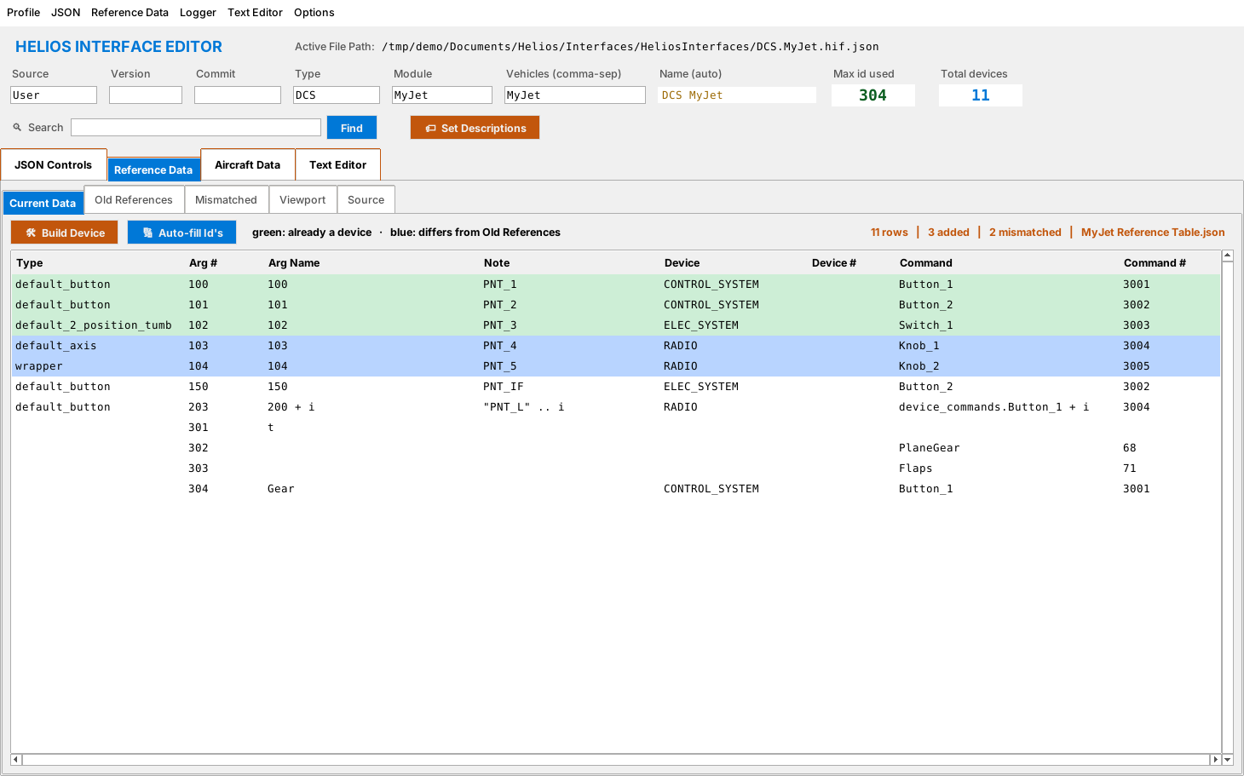
Figure 37. Blue rows differ from the Old Reference
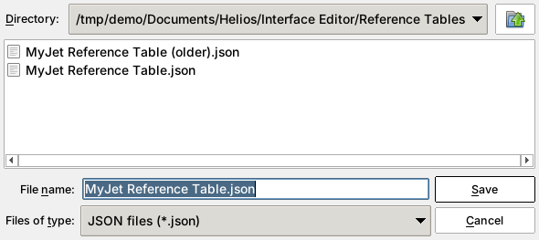
Figure 38. The save prompt for the reference table
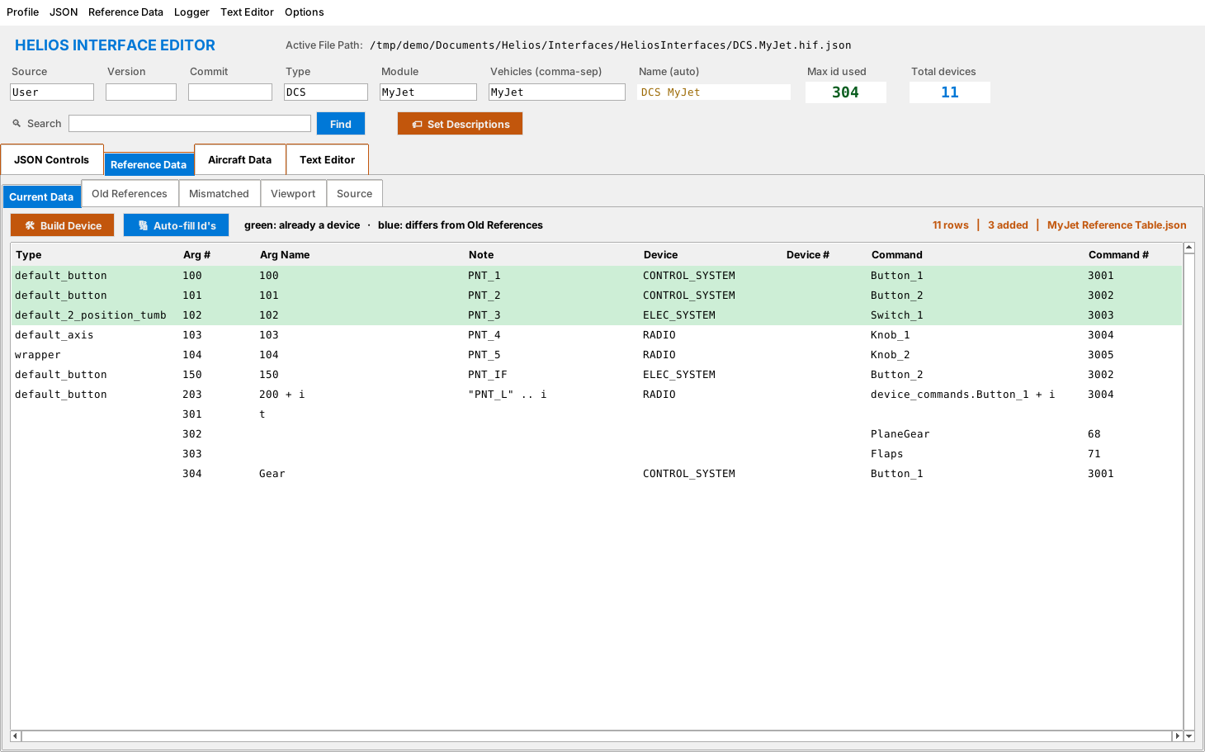
Figure 39. After saving, the status line no longer says "not saved yet"

8.3 Old References
This tab shows the table you loaded with Old Reference > Load…, in the same layout as Current Data. It is never modified unless you press Update on the Mismatched tab.
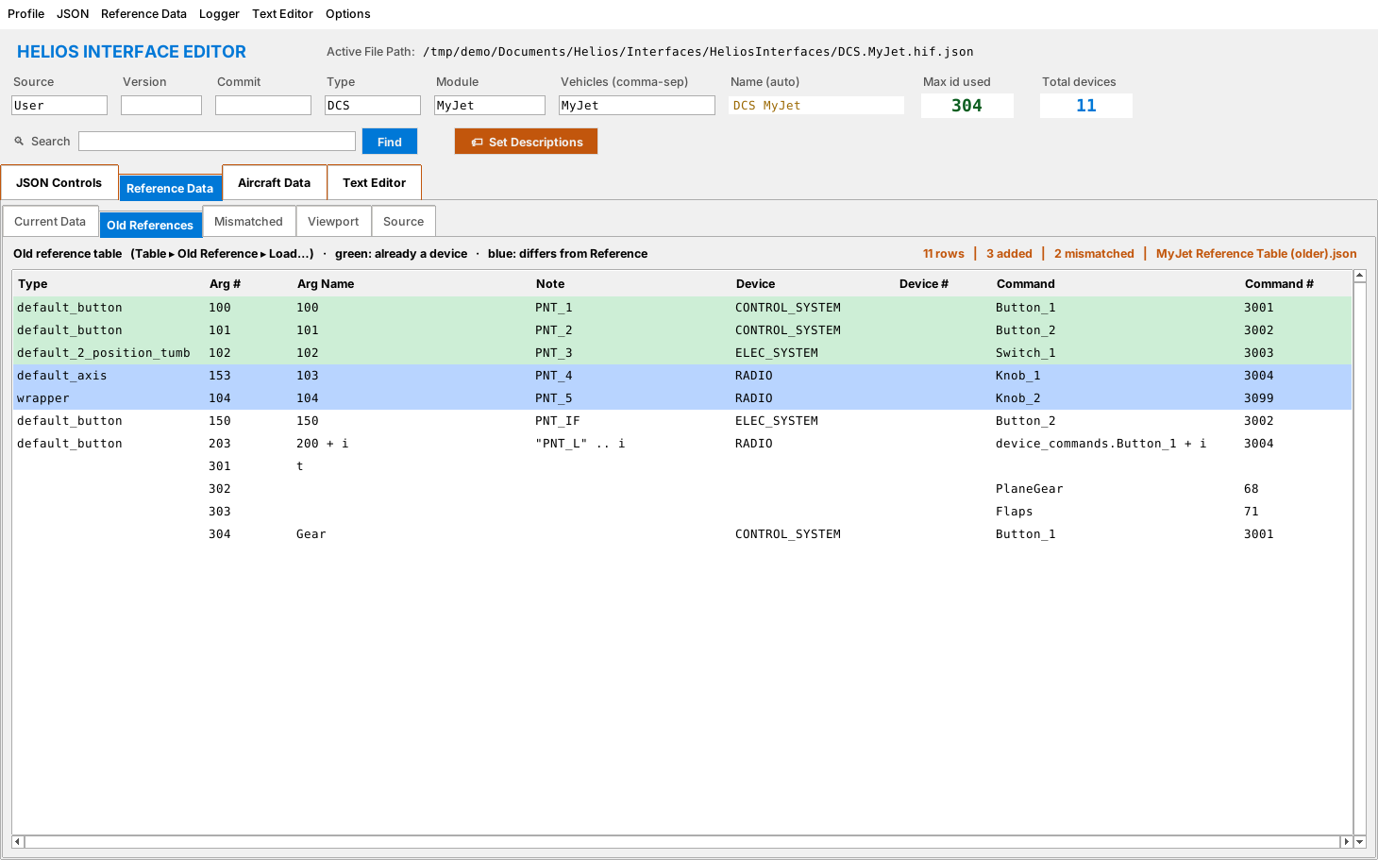
Figure 40. The Old References tab

8.4 Mismatched
The Mismatched tab lists every row whose values differ between the current and old tables, with old and new values side by side. Click Update to copy the new values into the Old References and into the matching interface devices.
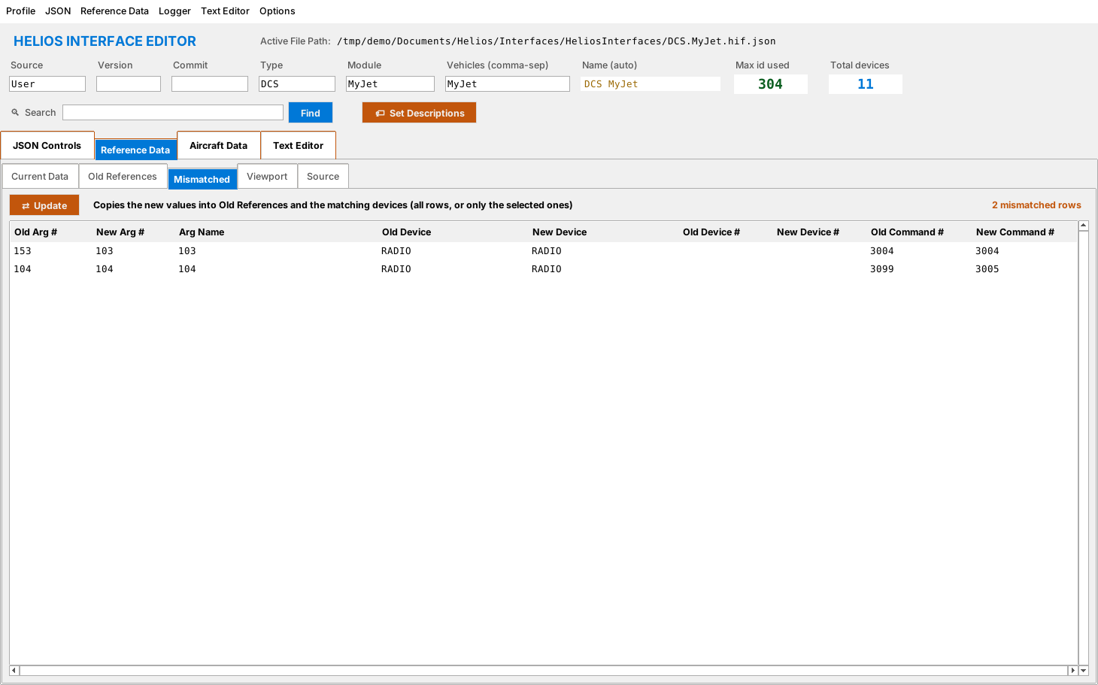
Figure 41. The Mismatched tab
Caution Update changes your interface. Save a copy first if you want to be able to go back.

8.5 Viewport and Source
The Viewport tab lists the viewport definitions (the named screens inside the cockpit). The Source tab shows where each row came from, meaning the Lua file and line that defined it, so you can open the file in the Text Editor and check it.
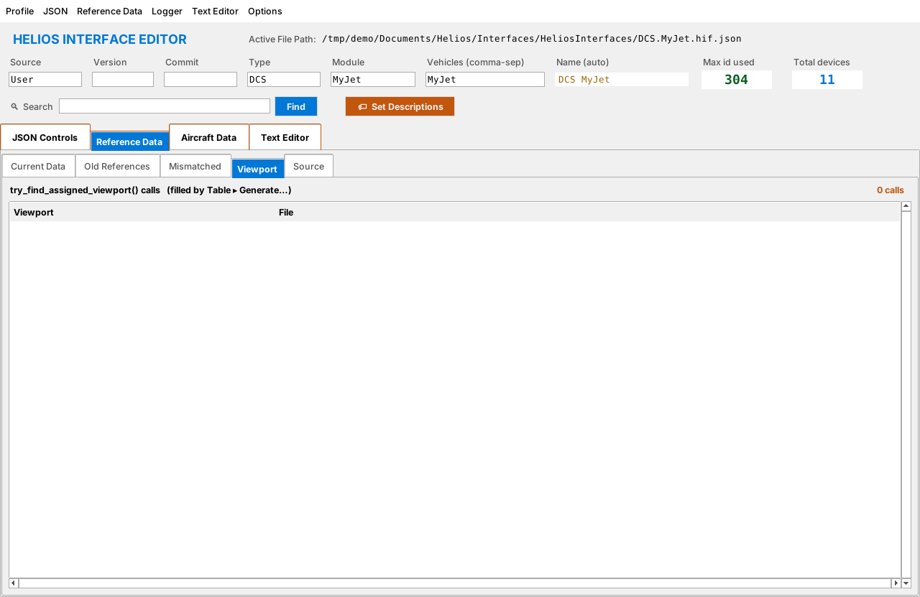
Figure 42. The Viewport tab
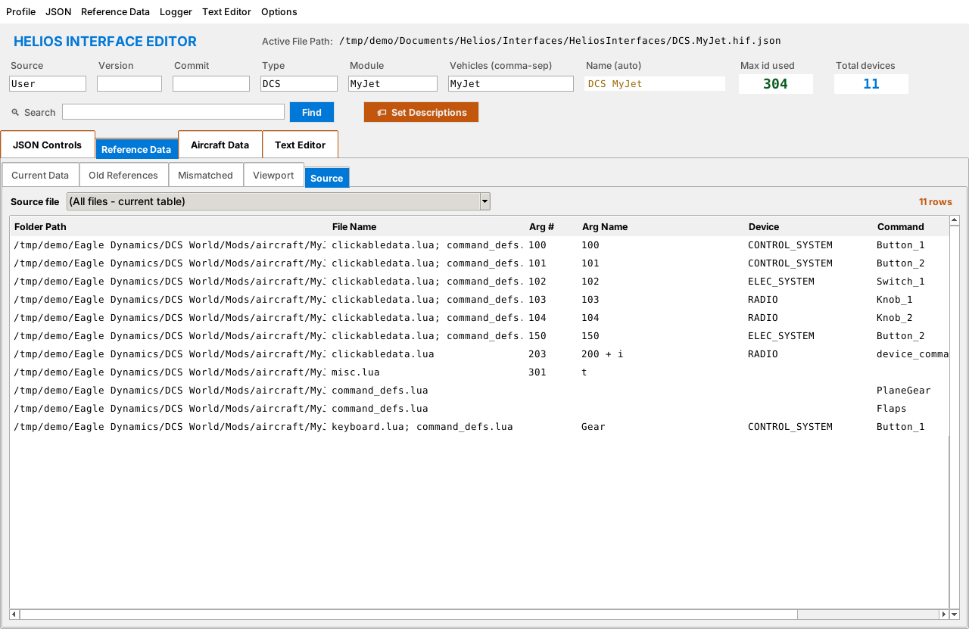
Figure 43. The Source tab

9. The Aircraft Data Tab (Argument Logger)
The Aircraft Data tab watches DCS while you fly and shows which cockpit values change when you operate a control. It is the quickest way to discover the Export ID of a control that is missing from your interface.

9.1 One-time setup: the export hook
The logger works through a small Lua script that DCS runs. The editor installs it for you.
- Choose Logger > Set Export Hook. (If the DCS Export.lua file does not exist yet, the editor offers Install/Repair now? when it starts.)
- Click Yes. The editor adds a single line to the end of your Saved Games\DCS\Scripts\Export.lua.
- Restart DCS if it was running.
Note The hook keeps exactly one line, always last in Export.lua. Running Set Export Hook again repairs it rather than duplicating it, so it is safe to use whenever the logger stops working.

9.2 Choosing what to record
Open Logger > Capture to choose which categories DCS writes to the log.
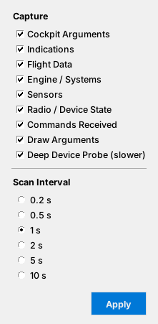
Figure 44. The Capture dialog
- Nine categories are shown: cockpit arguments, indications, flight data, engine/systems, sensors, radio/device state, commands received, draw arguments, and the Deep Device Probe.
- The Deep Device Probe is slower. Turn it on only when hunting for something the other categories miss.
- Set the scan interval (0.2, 0.5, 1, 2, 5 or 10 seconds). Short intervals catch fast changes but cost performance.
- Click Apply to send the choices to DCS.

9.3 Logging
- Start DCS and enter the cockpit of the aircraft.
- In the editor, open the Aircraft Data tab and click Start Logging. The status text changes to show scanning is running.
- Operate the control you want in the cockpit (flip the switch, turn the knob).
- Watch the table. Rows for values that changed appear, with their Previous, Current and Change.
- Click Start Logging again (it now reads Stop) when finished.
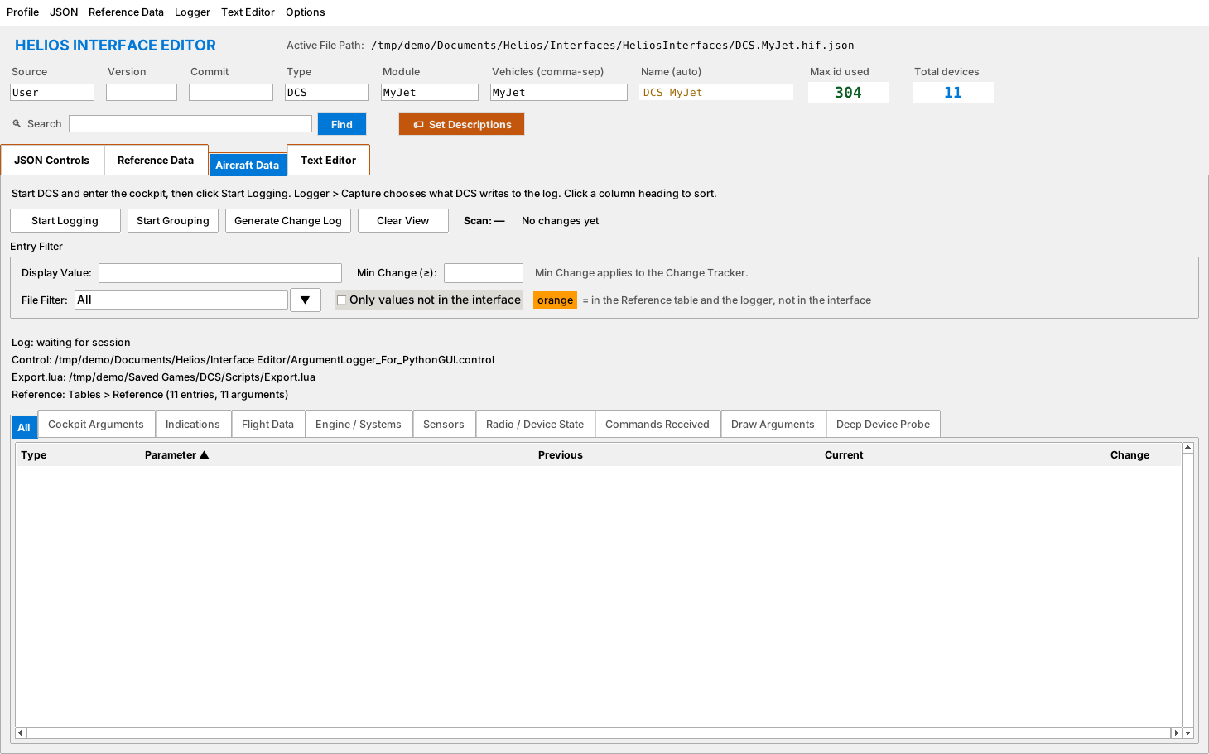
Figure 45. The Aircraft Data tab before logging starts
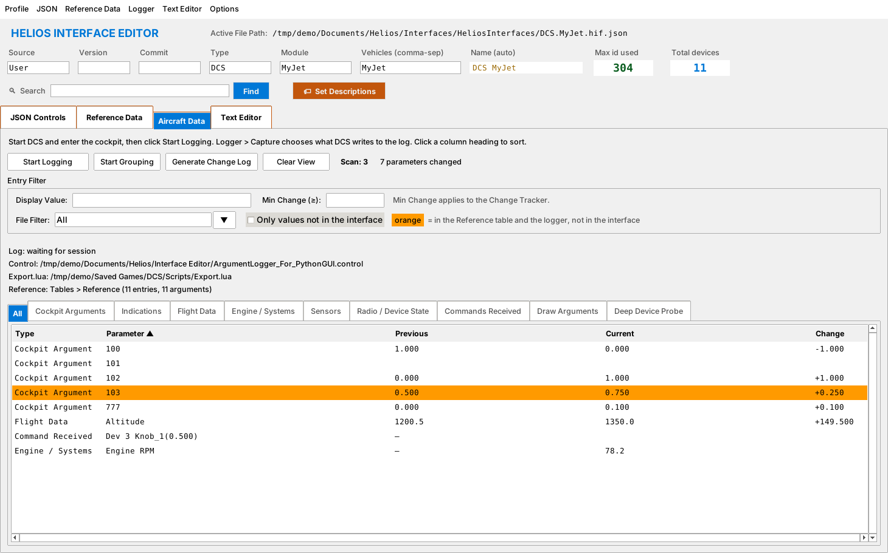
Figure 46. Changed values listed after operating controls
The table has one tab per category, plus All. The Cockpit Arguments tab, for example, shows only argument numbers.
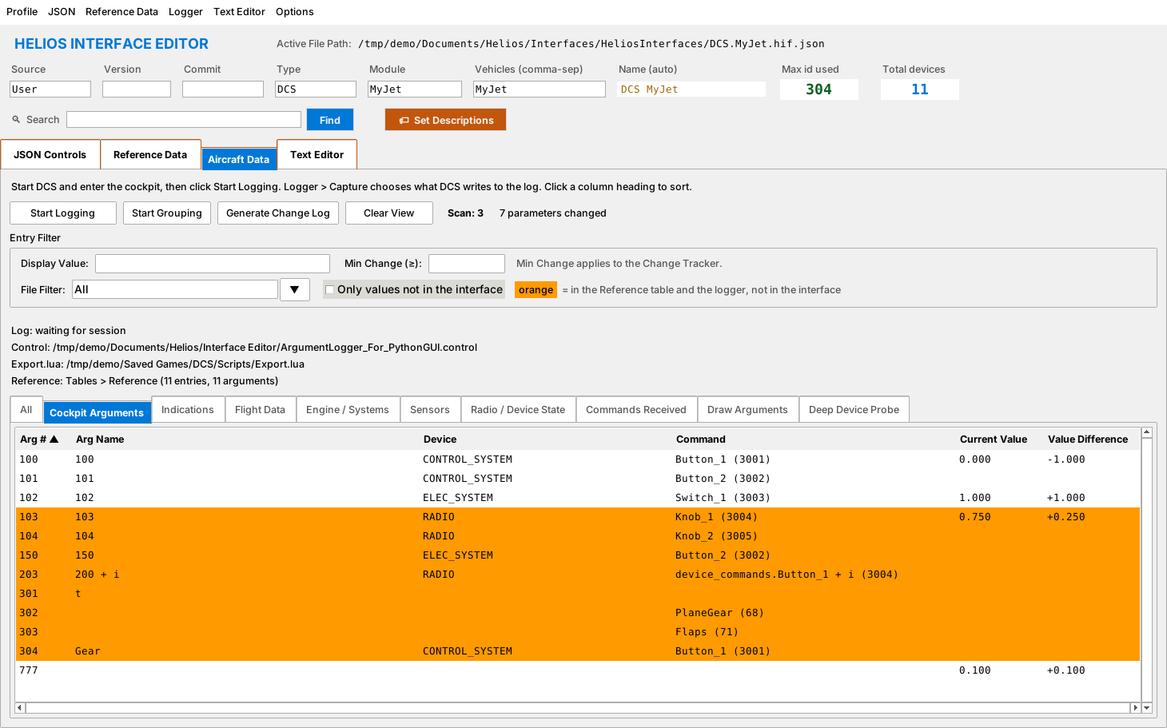
Figure 47. The Cockpit Arguments tab

Reading the table
Column | Meaning
Type | The category of the value.
Parameter | The argument number or name. Click the heading to sort.
Previous / Current | The value on the previous and latest scans.
Change | The difference. Click to sort by the biggest movers.
Rows in orange are values that appear in the reference table and were seen by the logger but are not in your interface. These are your missing controls.

9.4 Filtering
Control | Use
Display Value | Show only rows containing this text.
Min Change (≥) | Hide changes smaller than this number, to ignore noise.
File Filter | Show only values defined in one Lua file.
Only values not in the interface | Show only the orange rows.
Clear View | Empties the table without stopping logging.

9.5 Grouping commands
Click Start Grouping to open two windows. The Activity window lists commands as they are received; the Grouped Commands window holds the commands you collect. Select rows in Activity and click Add to Group to move them. In the group window, Add Device(s) selects the matching rows in Reference Data and starts Build Device on them (all rows if none is selected), and Remove takes rows back out.
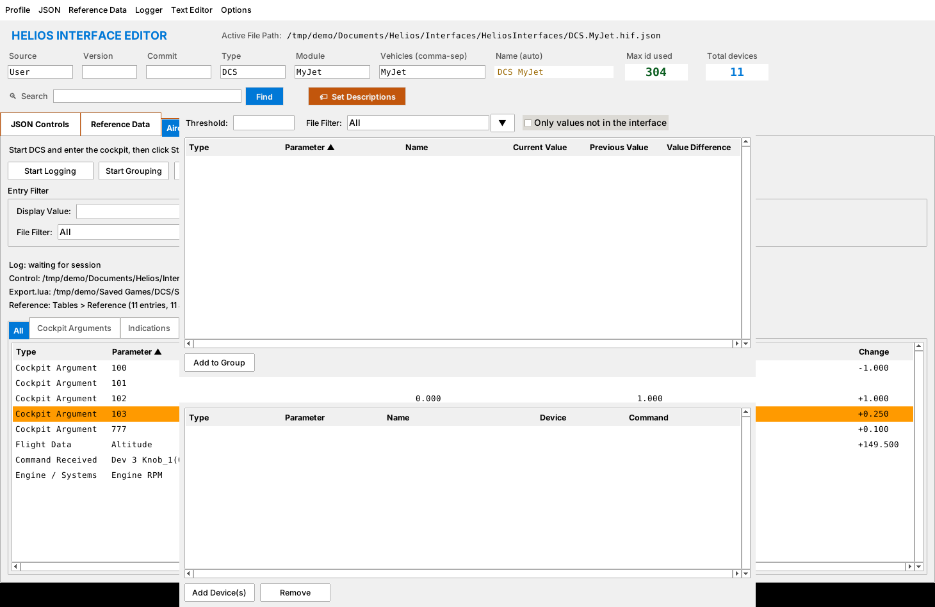
Figure 48. The Activity and Grouped Commands windows (overlapping here because the screenshot had no window manager)

9.6 Change log
Generate Change Log writes the rows currently shown in the selected tab, in the order shown and with the current filters applied, to a text file in a ChangeLogs subfolder of the log folder. The file starts with the time, the source log, the filters in use and the row count. Use Logger > Open Log Folder to find it.

9.7 Turning findings into entries
- Find the orange row for your control.
- Note its argument number.
- Go to Reference Data > Current Data, find the row, and use Build Device (section 5.3), or add the entry by hand (section 5.4).

10. The Text Editor Tab
The built-in Text Editor lets you open, read and change JSON, Lua and other text files without leaving the editor. It supports several files in tabs.
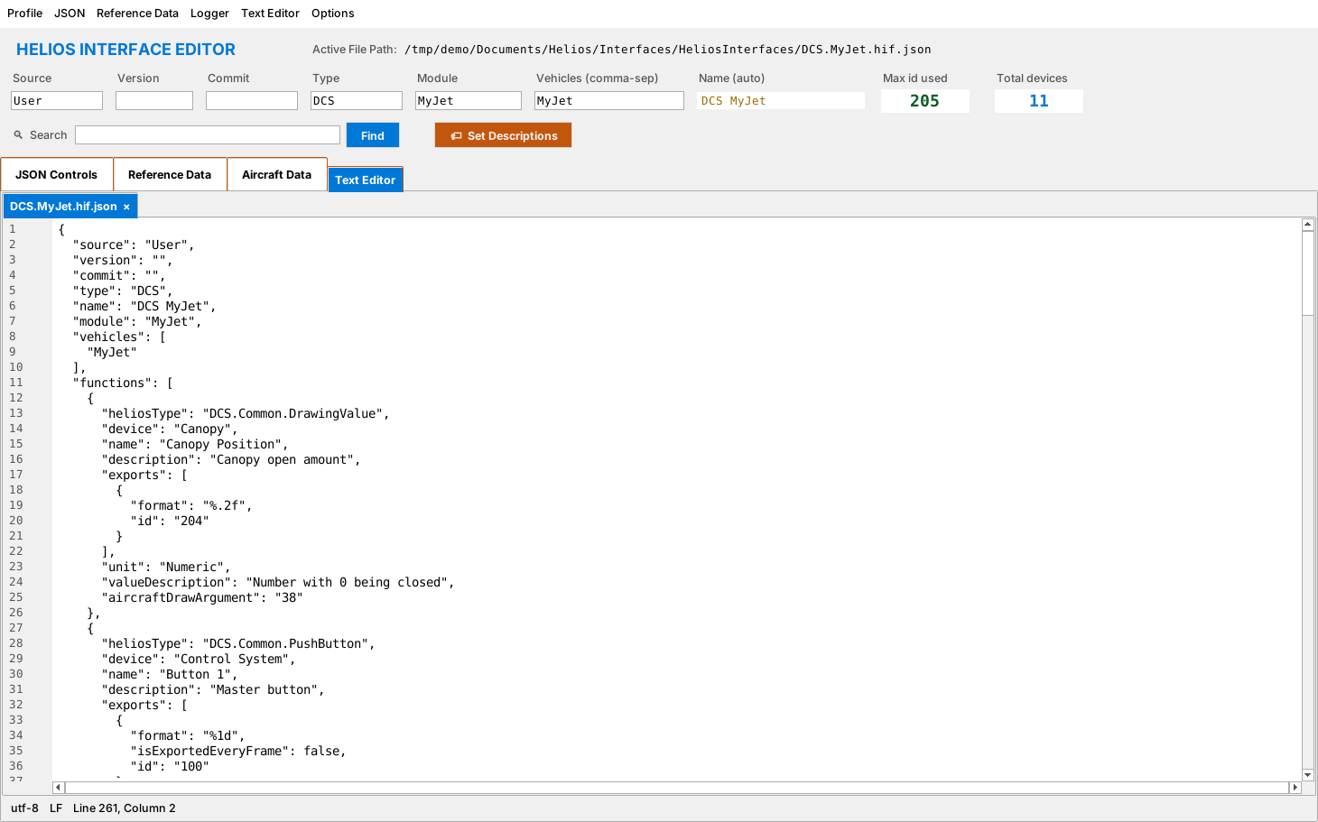
Figure 49. The Text Editor with an interface file open
Menu item | Action
New (Ctrl+N) | New empty file.
Open… (Ctrl+O) | Open a file in a new tab.
Save (Ctrl+S) / Save As… (Ctrl+Shift+S) | Write the file.
Close Tab (Ctrl+W) | Close the active file.
Edit > Undo / Redo / Cut / Copy / Paste / Select All | Standard editing (Ctrl+Z, Y, X, C, V, A).
Edit > Find… (Ctrl+F) / Find Next (F3) | Search inside the file.
Tools > Compare Current with File… | Compare the open file with another file to see the differences.
When you open the interface's own JSON file here, edits sync back to the interface, so what you type in the Text Editor and what you see on the JSON Controls tabs stay the same.
Tip Use Tools > Compare Current with File… to compare your interface with a copy from before an update, or with someone else's version.

11. Packaging a Profile
Packaging combines a profile, its interface, its images and installer information into one .helios16 file that anyone can install in Helios.

11.1 Before you package
- Run Check Bindings (11.3) and fix any problems.
- Save your interface and make sure the profile's images are in the Helios Images folder.

11.2 Packaging steps
- Choose Profile > Package (Ctrl+P).
- Fill in the form (below).
- Click the package button. The editor checks each profile's bindings (see 11.3; you choose Accept or Cancel for any profile with unbound devices), collects the files, and writes <Aircraft>.helios16 into Documents\Helios\Interface Editor\Profile Exports.
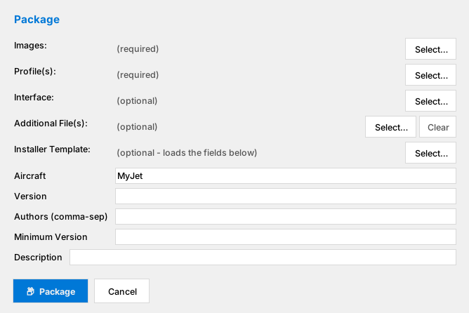
Figure 50. The Package dialog (empty)
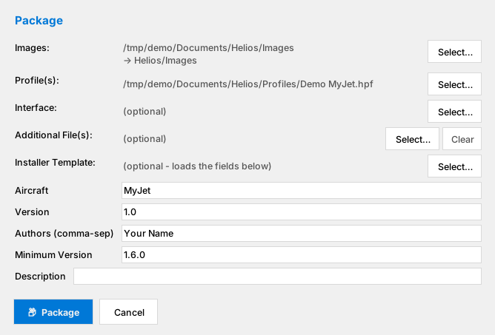
Figure 51. The Package dialog filled in
Field | What to enter
Images (required) | The folder or files holding the profile's pictures.
Profile(s) (required) | One or more .hpf profiles. Bindings are checked automatically for each.
Interface | The interface JSON to include.
Additional File(s) | Any extra files to ship.
Installer Template | Optional installer template file.
Aircraft | Aircraft name (used for the package file name).
Version | Package version.
Authors (comma-sep) | One or more author names.
Minimum Version | The lowest Helios version this works with.
Description | Optional. Leave it blank to use the version number. Long text is broken into lines: after 80 characters, the next space starts a new line, so a word is never split. With several profiles there is one Description per profile.

What goes into Profile16.json
Packaging writes a file named Profile16.json into the package. You do not type its message: it is built for you from this template, where each item in braces is replaced by what you entered or by the packaging date. Every line of the message starts with a tab, which the indent below represents.
Aircraft: {Authors} {Aircraft} Version {Version}
Requirements: Helios {Minimum} or above
Aspect Ratio: 16:9
Default Size: 1920x1080
Release Date: {Release Date}
{Authors} is the Authors field, {Aircraft}, {Version} and {Minimum} are the Aircraft, Version and Minimum Version fields, and {Release Date} is the day you package, written in the international year-month-day format (for example 2026-11-04).
The Description field of each profile is also written to the file. If you leave it empty, the version number is used instead, and a description longer than 80 characters is broken into lines in the same way: after 80 characters the next space starts a new line.

Missing and unused images
If a profile uses pictures that cannot be found, packaging pauses and lists them. Click Continue Packaging to carry on without them or Cancel to fix the problem. After packaging, any images in the folder that no profile uses are listed so you can leave them out next time.
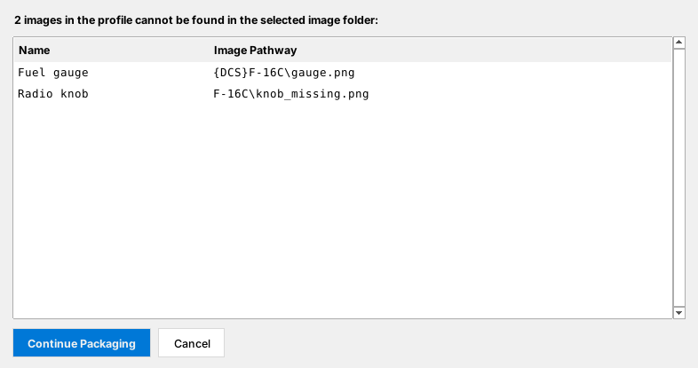
Figure 52. Missing images prompt
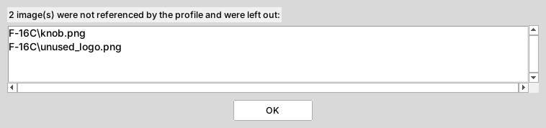
Figure 53. Unused images that were left out

11.3 Check Bindings
Profile > Check Bindings (Ctrl+B) tests every control in a profile against your interface and reports controls whose interface device cannot be found. When it is run from the Profile menu the window has a single Close button. Controls of kinds that do not need a binding (monitor, viewport, panel, label, image, text and input) are skipped.
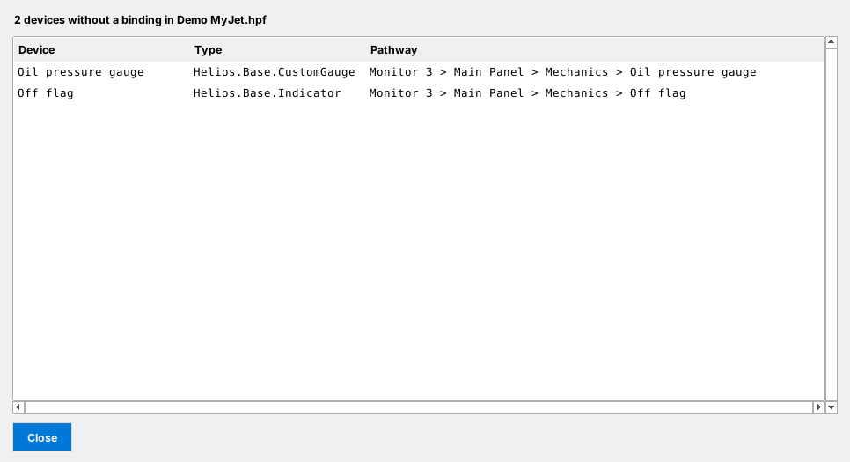
Figure 54. The Check Bindings report
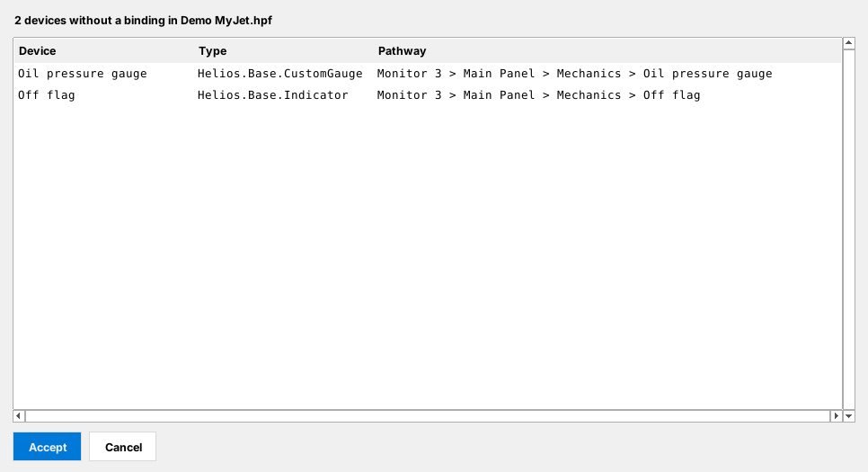
Figure 55. Binding results during packaging
While packaging, this window has two buttons. Accept keeps the profile in the package even though some devices have no binding. Cancel (or pressing Esc or closing the window) leaves that profile out of the package: it disappears from the Profile(s) row and its Description row is removed. In the sample profile two devices have no binding. To fix them, either add the missing entry to the interface, or correct the binding in Helios, then select the profile again.

11.4 Monitor Removal
Profile > Monitor Removal (Ctrl+M) removes empty monitors from a profile. Use it to shrink a profile before sharing. The edited profile is saved under the same name in Profile Exports, so keep your original elsewhere.

12. Appearance
Options > Color Scheme switches the colours of the whole editor. The choice applies instantly to all tabs and windows.
Scheme | Description
Default Palette | The light theme used throughout this manual.
Dark Mode - Default | Dark background with coloured accents.
Dark Mode - Grayscale | Dark background with grey accents only.
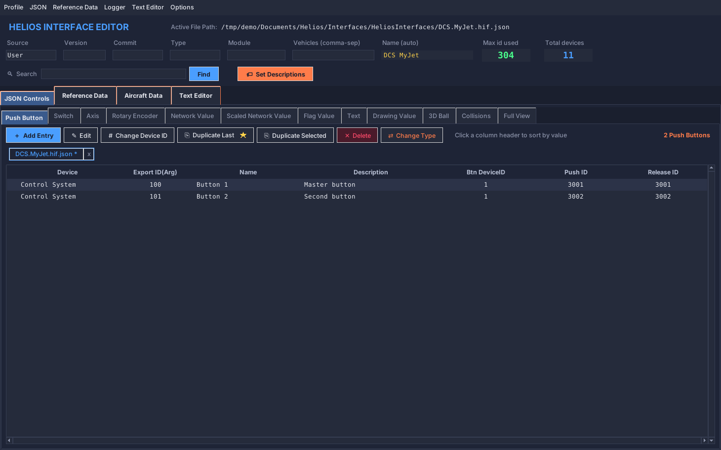
Figure 56. Dark Mode - Default
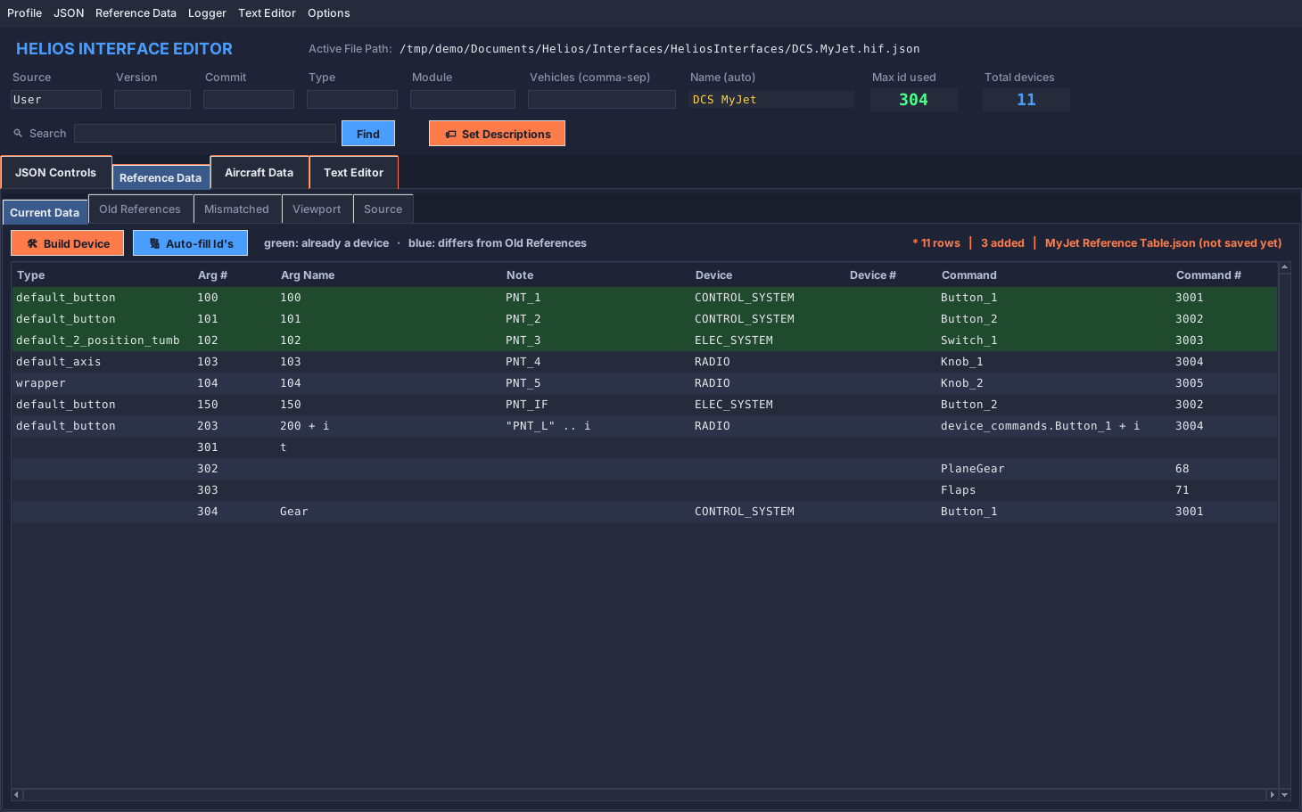
Figure 57. Dark mode on the Reference Data tab
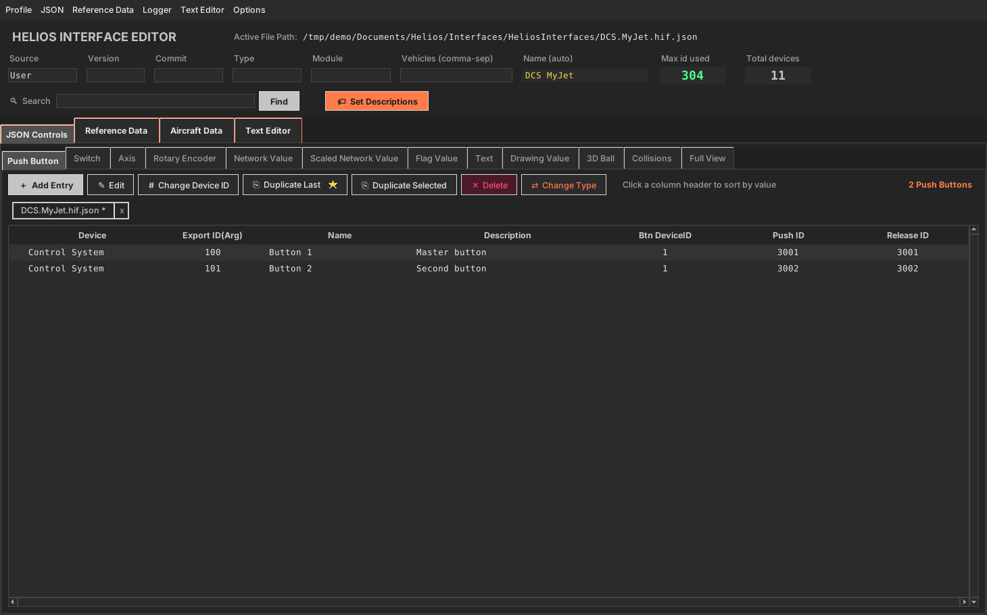
Figure 58. Dark Mode - Grayscale

13. Troubleshooting

13.1 Quick diagnosis table
Symptom | Likely cause | What to do
A control does nothing in DCS | Wrong Device ID or Action ID | Check the entry against the reference table; use the Logger's Commands Received tab while pressing the control.
A gauge shows no value in Helios | Wrong Export ID | Use the logger to find the correct argument; compare with the Cockpit Arguments tab.
Gauge value is in the wrong range | Missing scaling | Use a Scaled Network Value with the right Min/Max mapped values.
Switch positions are reversed | Argument values the wrong way round | Edit the switch and click Swap Argument Values.
Collisions tab lists groups | Duplicate IDs (often after Duplicate) | Change one ID in each group, press Refresh.
Logger table stays empty | Export hook missing, DCS not running, or wrong aircraft | Run Logger > Set Export Hook, restart DCS, then Start Logging.
Everything shows as changing | Noisy values | Set a Min Change filter, or use the Display Value or File Filter boxes to narrow the list.
Orange rows never appear | No reference table loaded | Generate or load a reference table first.
Build Device does nothing | No row selected, or all rows already devices (green) | Select a white row.
Package stops with missing images | Profile points to images that are not in the Images folder | Add the files, or choose Continue Packaging.
Check Bindings reports unbound devices | Entry missing from interface | Add the entry or fix the binding.
Dialogs look different on my PC | Screenshots were captured with Tk dialogs | Windows shows native dialogs; the options are the same.
Header shows wrong file name | Type or Module is empty or wrong | Fill in Type (DCS/Helios) and Module.

13.2 If the editor will not start
- Make sure Python 3 with Tkinter is installed (python -m tkinter opens a small test window).
- Check that Text_Editor_Prototype.py is in the same folder as the editor.
- Run it from a Command Prompt so any error message stays visible.

13.3 If a saved interface will not load in Helios
- Open it in the Text Editor tab and check that it is valid JSON.
- Look at the Full View tab to see exactly what is written.
- Make sure the file name starts with DCS. or Helios. and ends with .hif.json.
- Check Module matches the DCS aircraft name exactly.

13.4 If you lose work
- Interfaces are only changed on disk when you save. Reopen the last saved file with JSON > Open….
- Keep dated copies using JSON > Save As… before large edits or before pressing Update on the Mismatched tab.

13.5 A recommended maintenance checklist
- Generate a new reference table after each DCS update.
- Compare with the Old Reference and review Mismatched.
- Fix collisions.
- Run Set Descriptions for any new entries.
- Check Bindings against your profiles.
- Save with a consistent sort order.
- Package and test the .helios16 on a clean install.

Appendix A. Device Type Summary
Type | Best for | Reads (export) | Sends (action)
Push Button | Momentary buttons | Yes | Push and release
Switch | 2+ position switches | Yes | One command, values per position
Axis | Knobs and levers with a range | Yes | Set value
Rotary Encoder | Endless knobs | Yes | Increment and decrement
Network Value | Plain numbers | Yes | No
Scaled Network Value | Numbers needing unit conversion | Yes | No
Flag Value | Indicator lights | Yes | No
Text | Text displays | Yes | No
Drawing Value | Values from model draw arguments | Yes | No
3D Ball | Attitude indicator balls | Yes (X, Y, Z) | No

Appendix B. Glossary
Term | Definition
Action ID | The number of a DCS command.
Argument (Arg) | A DCS cockpit animation value; the source of exported state.
Binding | The link from a profile control to an interface device.
Collision | Two entries sharing an ID that should be unique.
Device ID | The DCS number of a cockpit device (the thing that receives commands).
Export | A value sent from DCS to Helios.
Export hook | The Lua line that lets the logger read DCS.
.hif.json | Helios interface file.
.hpf | Helios profile file.
.helios16 | Helios package file.
Mapped value | A real-world number that a raw DCS value is converted to.
Reference table | The generated list of arguments, devices and commands for one aircraft.
Viewport | A named screen area inside the cockpit that Helios can display.

